REPORT on Training of Trainers for the capacity building of Paralegals in Odisha
NATIONAL LAW UNIVERSITY, ODISHA
29th March- 31st March, 2017
INDEX

S. NO. | CONTENT | PAGE NO.
1. | Introduction | 2
2. | DAY 1  Session I  Session II  Session III | 3  6  8  15
3. | DAY 2  Session I  Session II  Session III | 20  22  25  27
4. | DAY 3  Session I  Session II  Session III  Session IV | 35  37  41  42  44
5. | Concluding session | 45

Introduction

The South Asian Institute of Advanced Legal and Human Rights Studies [SAILS], in association with BRAC University, Bangladesh and IDEAL Centre for Social Justice [CSJ] organized a ‘Training of Trainers for the Capacity Building of Paralegals in Odisha’ from 29th March to 31st March, 2017 at National Law University, Cuttack, Odisha. The workshop was organized in furtherance of the overall vision of SAILS, BRAC-U and CSJ to build a cadre of legal professionals across South Asia who will further and promote the ‘paralegalism’ movement, by training trainers and paralegals for the legal empowerment of the poor and ensuring access to justice for the overall development of the South Asian region.
The Training of Trainers Workshop was attended by 30 participants from all over Odisha. Over the three days of the workshop, the master trainers’ capacities were built on designing training sessions for paralegals, by incorporating principles of adult learning and alternative legal education. The training workshop was holistically designed keeping in mind the needs of the trainers especially in the context of Odisha.
This report captures the workshop’s proceedings including the pedagogy used and the concepts behind it along with insights from the group of participants, and aims to be a learning document of sorts for capacity building in access to justice which will lead to building a discourse around the ‘paralegalism’ movement in South Asia.

Day 1
29th March, 2017

Inaugural Session

- Introduction

- “Introduction to the training programme”, Ms. Nupur, Executive Director, Centre for Social Justice (CSJ)

Ms. Nupur began the event by welcoming the participants on behalf of CSJ. She mentioned that, she has been conducting training for many years and for mainstream training we need collaboration of social organizations and academic institutions. Thanking NLUO for providing CSJ the space, Ms. Nupur highlighted the following as the objectives of the training:
- To provide a platform for mutual learning and sharing.
- To further enhance skills in educating for legal empowerment by building on existing best practices.
- To identify best practices in managing legal empowerment programmes.
- To develop principles to be followed while designing a capacity building programme for legal empowerment.
- To explore spaces for policy advocacy for legitimizing the role of paralegals.

Ms.Nupur then invited Mr. Shahariar Sadat and Ms. Nilufa Sheta to introduce themselves briefly to the participants.
Mr. Sharia Sadat, Academic Coordinator, Centre for Peace and Just Society, BRAC University, Bangladesh. He mentioned that their work included working on Goal 16 and Legal empowerment which is carried out in collaboration with CSJ. He thanked NLUO for giving the space and time for the event as well as CSJ for technical support.
Ms. Nupur then invited Professor KD Rao, Vice Chancellor of NLUO to briefly introduce himself to the participants. Mr. Rao mentions how everyone present are coming with brilliant experience at the grassroots level. Law in books and in reality is different. The challenges in the last three to four decades of the civil society in India has been to transform. Legal empowerment is a value loaded word. Paralegals assume importance in Indian context. He said that, we have wonderful laws, the Supreme Court and international Human Rights principles and other great commissions. Human Right groups, SC and several of these academic institutions are working in their own spheres. Sustainable goals are assuming importance in global sphere. Mr. Rao concluded by saying that, at NLUO conscious effort is taken to make law a reality through the education system.
Adding on to that, Ms. Nupur elaborated that, the training event is not a lecture based programme. Everyone’s participation was required as everyone is a source of knowledge.
Mr. Shahariar then shared the broader perspective of the event. He mentioned that legal empowerment programme is part of BRAC University- Centre for Peace and Just Society. Drawing from his experiences he mentioned that, there is often a lack of connection between the citizens and legal system and he feels that paralegals can play an important part. BRAC University- CPJS in collaboration with CSJ has organized TOTs over the last 2 years, in Srilanka, Dhaka, Islamabad and Nepal. The objective being how we can take the paralegal movement forward. Mr.Shahariar elaborated how last year a paralegal mapping workshop was organized. In Bangladesh they came up with a 3 step process. It can be defined as basic module, advanced and then the TOT. At part of first step, they convened a committee, they compiled basic modules for paralegals. They looked at various legal aid organizations and their modules and then combined it into module material. Following which one field test and training programme was conducted and consolidation of the basic module will be completed by April. After which the same will be translated and posted on websites.
These are the national processes. We share the experiences in different places. In India the process is streamlined and developed and we are looking at Nepal and how to develop that. The larger vision is South Asian paralegal system which will be recognized by government. We have to do lot of advocacy so that we can draw parallels and show the experiences of neighboring countries as well. In fact, if paralegals can be rightly identified then targets of Goal 16 can be achieved.
Ms. Sheta then explained that, they are concentrating on South Asian countries, especially on neighboring countries for now. The process is based on country specific needs. The TOT was designed so that after this the participants could see how they wanted to see the paralegal programme shape in future, and how they would take this learning ahead. When asked for review from these paralegals who were from remote areas, most of them were of the view that they never thought that learning law was so easy.
Ms. Nupur:
We learn from each other. And bring out bets practices. What has worked and what has not. What is happening after training, and what hand holding is required. Each group is different, all different groups and designed. Legal intervention.
Thereafter, Ms. Nupur laying emphasis on the importance of a formal introduction of everyone requested the participants to individually answer the following questions:

- My name and my organization.
- One expectation from this workshop.
- What legal empowerment means for me?

The following is a summary of responses from some of the participants:

Name and organization | One expectation from this workshop | What legal empowerment means to you
Upma Mohanty, Peacock | What should be the exact role of a trainer and paralegal in the present society | What is legal and illegal? When a person’s right is violated, where to go and how can I demand justice, the answers to these questions is legal empowerment.
Purshottam Sahu, CLAP | How to administer legal aid at block level. What is their activity and what are paralegal activities. | Legal Empowerment means facilitation in a self introspection way. I should have the basic knowledge and know when, where and how to proceed.
Hari Shankar Rout, SWATI | To know more about legal system in India and use that at the field level. | Everybody should know what is law, its relevancy, benefits and reliefs. Empowerment means every kind of Access to Justice.
Sandeep Kumar Padhi, Paralegal Student, NLUO | Learn basics of law and carry forward the same. | Citizens should know what their rights are. Knowledge about law and access to justice framework.
Centre for Youth and Social Development | How to develop training module for our paralegals. | To get justice without any hassles.
Surojit Sen, CLAP | Role of paralegals and advocacy | Legal empowerment should be self- protection tool, when the society itself is able to stand up for their rights.
Bijoy Kumar Panda | Knowledge from eminent personalities in the field.
Jitendra Kumar Ray | How poor people can access justice

After the exercise of brief introduction, and drawing from everyone’s responses, Ms. Nupur shared some insights on training designs:
- Personal Experiences: She mentioned that, the event is not so much about law as it is about drawing experiences of the field from everyone and using that to help al other participants in the training.

- Open mind: It is important that we keep an open mind when we are learning. The definition of ‘paralegal’ is different for all and thus the idea is to gain from all the experience that everyone comes

Session I

- Methodology:

- The participants were asked to first spend 5 minutes individually recalling 2 important moments in their life :-
- One when you were up to 7 years - An incident or moment you vividly remember as having learnt something for life.
- One in the last 7 years - An incident or moment where you supported/ facilitated somebody else’s learning and that person acknowledges it till today.
- They were asked to share their stories in the group and draw out common factors that supported learning for them and practices which helped others learn. They would then agree on top 3 or 4 on both and present on flip charts. They were given 20 minutes for sharing their stories and another 10 minutes for discussion and presentation on charts.

- Conceptual underpinnings:

The idea behind this exercise was to understand “how do we learn as trainers and learners”. To convert experiences into principles, a skill which is essential for a trainer. It is an attempt that we try and draw from experiences and deduce them to principles. What we are trying to do is to derive principles via stories. Personal experiences are a great way to learn from it. Each individual will learn and get a holistic idea as to how that person is as a learner and as a trainer.

- Insights from the group:

Groups | One moment up to 7 years | One moment in the last 7 years
1 | - Not to interfere in matters that we don’t know about  - To help others in their own capacity  - Learn to save life  - Personal experiences | - Legal assistance  - Worked for child protection and legal support  - Protection of forest  - Suggested to be a responsible mother  - Learning from disaster
2 | - Learning how to protest against injustice  - Learn how to struggle for life  - Learn to maintain a dignified life. | - Small help can create a greater impact  - Practical experience can lead to positive result  - Little effort of motivation can lead to change.
3 | - Unconditional care for parents and old-age parents in need. Engagement of real life issues.  - being victimized, personally feeling trauma | - Practical engagement with the problem of domestic violence  - Engagement with the process of imparting education, free of cost  - Practically inclined towards the idea of mutual help.
4 | - Learning by doing process. Help in adverse situations.  - Taking precautions at the time of work.  - Apply presence of mind during emergencies.  - Little learning is a dangerous thing | - Help is needed in case of accidents.  - Practice makes a man perfect.  - Learning how to tackle difficult situations.  - Follow up with past cases.

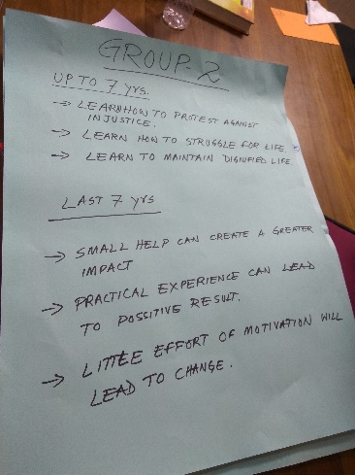
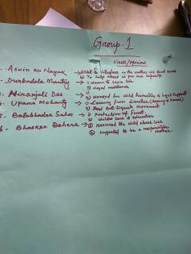
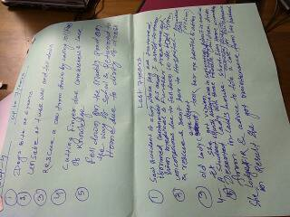
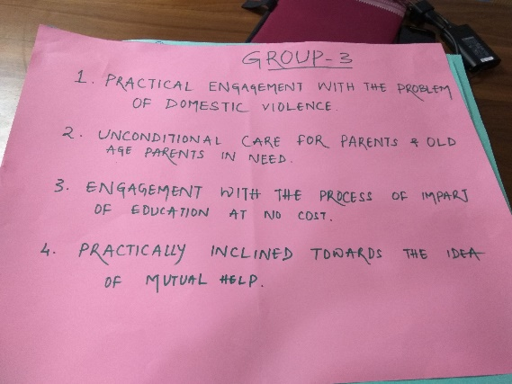

IV: Inputs from the trainer:

Drawing from the output of the groups, the trainer provided the following inputs on the activity and its purpose:
- The trainer cited some personal examples of her own learning of her life till 7 years and one moment in the last 7 years. Absence of negative environment and presence of positive environment fosters learning.

- The trainer cited her own learnings from a TOT in Nepal where she elaborated the steps in the exercise to the participants present, however she did not explain the steps. The work couldn’t be completed by them successfully that night. The next day she cited the steps again, but this time by elaborating each step and instructions. The work was completed in 15 minutes. It is seen here that the trainer learnt from her failures, so as to not to repeat them. She was able to learn from the reason of her failure. Other factors contribute to learning.

- It is important that we understand how we learn when we were 7. Secondly, what we taught in the last 7 years. How I learn and how I train. It is to understand both these questions. It is an attempt to clarify yourself as a trainer and learner. It is important that we talk to our self so that we get a holistic idea as a learner and trainer.

Session II

“Metaphorizing the Access to Justice Framework”

The trainer captures the essence of a ‘metaphor’ in the following words:

- Metaphor is the technique of explaining one thing in terms of another.
- Metaphor is a way of creating new ideas and understandings.
- We are mostly scanning to see the familiar in new things.
- Metaphors are not solutions: they are invitations to explore new situations with fresh perceptions.
Importance of metaphors:
- Metaphorical thinking is the ability to make connections between two unlike things, by recognizing an inherent similarity or a common trait.
- “Making the familiar strange."
- Promotes synthesis, integration, and evaluation of the learning.

- Methodology:

Metaphorizing the A2J System:

The participants were shown different pictures of an ecosystem, where they were asked to choose any one ecosystem or make one of their own. The participants were divided into smaller groups of 5, where as part of the exercise they were asked to compare and mark the different actors of access to justice system in their area. After marking the actors, locate the paralegal in the system. Present on charts. Eg. A deer in a forest ecosystem, can be a victim in the access to justice system.

Constructing the A2J world:

The participants were then asked to present their A2J ecosystem in the plenary. What are the common elements that you can identify about the paralegal and their role from all the elements.

Opening the world of Paralegal:

Who is a paralegal? The next steps to the aforementioned activity were:

- To take the object/creature that they have related with the paralegal in the previous exercise. Flesh out the object/creature more and add description like colour, size, texture (if it is an object) or body parts (if it is a creature).
- To list 7 body parts /aspects that they can relate with the various attributes of a paralegal. Eg. Eyes can be attributable to foresight, which is an attribute desirable in a paralegal.
- To develop a definition of a paralegal in its relationship to the A2J ecosystem.

- Conceptual Underpinnings:

- Metaphors are ways of finding similarity between unconnected things.
- As a trainer metaphorizing entails using both parts of the brain. It deals with both left and right side of the brain. Enhancing creativity and logic. As trainers we should be able to look at inter-connected thinking and not by segments. Always integrate and not segregate.
- Definition of a paralegal: everyone is coming with their varied experiences. It is an attempt to come to a shared understanding so that we can have a definition of a paralegal. Who is a paralegal and his activities.
- Metaphorizing helps in finding similarity between unconnected things/objects, and this exercise furthered the idea of Access to Justice System and how it functions.

- Insights from the groups:

The responses of the groups are captured in the following table:

Groups | Nature of ecosystem | Actors of A2J System | Who is a paralegal (creature/object) in the ecosystem? | Definition of a ‘paralegal’
1 | Natural ecosystem | - Role of baba is praying to the sun. Sun here is the legislative body which makes rules.  - Trees are the legal service authorities as they provide shade to the passer-byes like the legal service authorities.  - SLSA-DLSA-HC committees are present in the ecosystem.  - Goat is like the police. It is helpless.  - Fish in the pond is the victim. It is eaten up by the crane which is the offender.  - Tortoise is the paralegal. When fish are eaten up by the crane then tortoise will swim to the shore to inform the goat regarding the violation.  - Tiger is present which is very powerful. | The paralegal here is the tortoise:  Shell- protect and work within the limits.  Eyes- vigilant  Ear and mouth- to hear problems of victims and speak as required.  Nose-to smell and adjust  Neck-to act as per situation  Front leg- to rescue victims and guide them to appropriate authority  Back leg- for mobility. | “one who acts as an intermediary between victims and appropriate authorities”
2 |  | - The house depicts a Court  - The bars are trees.  - Butterflies are like law colleges, which sit on the flower pollinates.  - Students are like flowers.  - The frog is a victim and as the snake is eating the frog, it is the accused.  - The Boat is a paralegal because it can cross the river safely carrying people. | Here the paralegal was the Boat:  Oars to help in move in the right direction.  The space inside the boat is to help accommodate everyone.  The back of the boat is to help in giving direction  Rope so that one can access the boat  Handles of the boat to help in facilitation  The main base of the boat which helps in facing hurdles and cross safely. | ____________
3 | Forest ecosystem | - Deer is the victim as it is caught in a net  - Crow is the paralegal which alerts everyone to free the deer.  - Elephant is an advocate, because it is intelligent.  - The Lion is the judge because it is king of the forest.  - The center of the forest is the Bar Association with its many advocates.  - Different animals represent the community at large and diversity.  FB: they needed to clearly make understand the others the link between metaphors. | The paralegal here is the Crow- its 7 components:  Wings for representation  Eyes for observation  Feet for justice facilitation  Beak for collection of evidence.  Stomach for effective documentation of incident.  Brain for conducting legal service clinics.  Heart for facilitation of negotiation and conciliation between parties. | ___________________
4 | Desert Ecosystem | - In a desert ecosystem, the elements are limited and everything happens on sand. The sand is the judiciary.  - The eagle/vulture is the offender in the system.  - The Victims are the snake and lizard, as eagles feed on reptiles.  - The Desert Fox is the police as it is cunning and is never alert for any crime suo moto.  - The cactus is the witness as it is witnessing all the activities happening around.  - Scorpion plays the role of an advocate. It is either deliberately delaying or immediately coming into effect.  - The Camel is playing the role of a paralegal in the ecosystem. It is equally friendly to each and every element and it is familiar with everyone.  - There is also present an illusion as a hindrance to the vision of the camel. It is delaying the justice for years. Camel is experiencing the mirage effect, it is actually delay in justice.  - The Sun is the government which does nothing but is always present. | The paralegal in this ecosystem is a Camel.  Eyes for accuracy  Nose for sniffing violations.  Hump for conserving energy as a driving factor.  Tail for direction/prevent distraction.  Ear for vigilance.  Flesh- there should be thickness of flesh so that there can be resilience from criticism.  Brain for intellectual capacity  Feet to have the strength to go long distances. | ________________
5. | Ecosystem of society | - A person is present who is the accused as he is cutting the trees.  - Trees are victims.  - When we cut trees it effects the ecosystem.  - Other members and people are paralegals in the system. | In this ecosystem the paralegal was a person- it’s 7 components being:  Head  Eye  Ear  Fingers  Mouth  Heart  Hand  Body- energy for all activities | _____________________
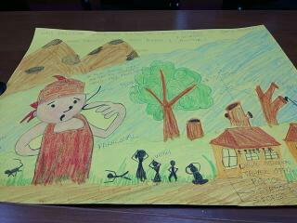

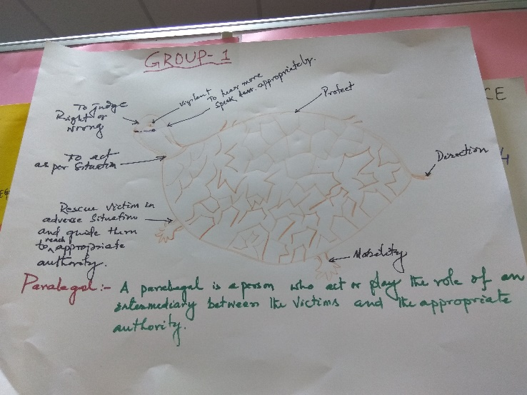
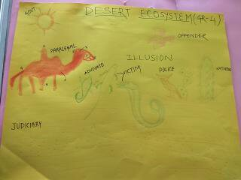

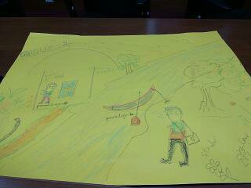
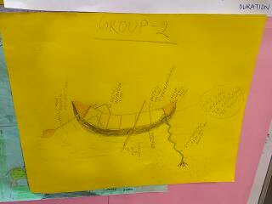

- Inputs from the trainer:
Definition of paralegal is different for everyone. Who is a paralegal? From the previous exercise we will try and figure who is a paralegal, since everyone has identified that one object/thing which is a paralegal in their ecosystem.
While it was a good effort made by most of the groups, the trainer advised Group 5 to think more on the lines of metaphorizing the Access to Justice System.

Session III

“CSJ’s work and engagement with the paralegal movement in India”

The trainer then shares the work of CSJ, in the field and work with paralegals. The trainer says that often we see that in our social movements, the knowledge of law is usually nominal but consists of a lot of mobilization. However, lack of knowledge of law makes us unsuccessful.
The identity of a Paralegal is a diminished identity. Who is paralegal? Paralegal is not a lawyer. Rather than replying in the negative, we should start answering the question as to who a paralegal is.
Scope and role of paralegals:
We can learn about it in the following ways:
- One shot capsules on law can be adopted, where we call the paralegals for about 10 day training and overload them with information regarding law.
- Experience the practical reality at the field. Learning by doing.
- Any organization training paralegals on specific issues, eg. Dalit rights or women’s rights.

CSJ’s initial steps towards this were to establish that paralegal is an identity. It is a specific cadre. It required a person to have identified a specific number of cases and made a certain number of claims. Only attending a 10 day certificate course was not the parameter to be a paralegal. It was said that a paralegal was a social worker plus. Every good social justice advocate should be a good paralegal. He is more than a lawyer.

CSJ tried not only to spread awareness but the approach was towards a systemic intervention. We also tried to identify spaces for paralegals for their effective functioning in this field. We formulated few categories:

Categories of paralegal:

- Single issue, single skill
- Single issues, multiple skills: Eg. If an organization is working for women’s rights in that case the organization should be able to arrange for legal awareness on women’s rights, fact finding, counselling etc.
- Multiple issues, multiple skills: Eg. An organization working on various issues, they need to develop different kinds of skills.

CSJ further categorized the different levels of paralegals, keeping in mind the different level of knowledge to be imparted to paralegals at different levels via trainings.

Levels of paralegals:

- Level Zero- Has general information on law, is a community leader and helps us in organizing meetings and fact finding.
- Level 1- has the ability to identify violations, refer them to us.
- Level 2- has the ability to address violations, give first level support
- Level 3- does everything that a lawyer does except appearing in court.

Strategies used by CSJ:

- Identifying spaces within government mechanisms. For example: forest committees, Lok Adalats, Police Adalats etc.
- Training paralegals and then co-opting them in government mechanisms. For example: paralegals being appointed in Gram Panchayat, or as a sitting member in any committee.
- Lobbied with departments under various acts (For example: under the Gram Nyayalay Act a paralegal can appear officially even if no lawyer is present). To create spaces and legitimizing their role as a paralegal.
- Network of paralegals to improve transparency and accountability.

Models successful:

The principle that is followed by CSJ is Input-action (at the fields)-reflection (on the actions based on experience from the field)-fresh input.

Creating spaces for legal awareness:

- The idea is to look out for such local events where such knowledge can be shared within the community. Weekly haats or local markets held at the villages are effective spaces which can be utilized for awareness visits, shibirs. One paralegal-volunteer will be responsible for arranging this meeting for us. He/she will also be responsible for bringing cases from that village.

- Identifying spaces where village actors who come together for meetings: Anganwadi Centre meetings.

- Organizing events every month for 2 days or 2 events in a year etc. are different models which can be adopted.

Success stories of CSJ’s Paralegals:
The trainer then discusses some success stories of paralegals trained by CSJ.
Lakshu, an adivasi paralegal who is now handling all revenue cases in the village.
Sushila, who was not very educated when she came to CSJ. However, she completed her education and graduation in law and is now currently practicing at the District Court.
Nilofar, a congress member now runs her on center.
Therefore, the identity of paralegal has many avenues where he/she can map his/her own growth path.

Levels of paralegals:

Level of paralegal is not dependent on its qualifications. Even an established lawyer can be a Level Zero paralegal, depending on its role.

What is Competence?

The trainer elaborates on what defines ‘competence’. Competence means:

- The ability to do something successfully or efficiently.
- A combination of required information, skills and attitude.
- A cluster of related abilities, commitments, knowledge, and skills that enable a person (or an organization) to act effectively in a job or situation.
- Competence indicates sufficiency of knowledge and skills that enable someone to act in a wide variety of situations.

- Methodology:

- The participants are divided according to their respective organizations, i.e into 4 groups of CLAP, SWATI, Peacock and CYSD. One person from each organization is asked to be the representative of their organization while other participants are divided into these 4 groups of organizations.
- Take any one organization for whom you will plan.
- Imagine a group that you will train in future depending on the field area. Eg. Adivasis, dalits etc.
- Freeze the level of the group according to your organizational needs, and develop the competency grid.

For example: for a Level 1 paralegal working on women’s rights, the paralegal should have access to the village especially with women, understanding violations. Therefore, what information, skill, and perspective is required for this particular paralegal?

Competence= Perspective+ skill+ information
Competence | Perspective | information | Skill
Problem identification | Gender sensitive | Domestic violence related | Interviewing
Group level | High | Low | Medium
2.
Group level | medium | Low | High

Time allotted for identifying theme, level of paralegal and making competency grid: 30 minutes.

Materials used: chart paper, markers, pens
Capacity Building plan for Bhopal unit distributed to the participants.

Conclusion of Day 1:

The trainer asked all the groups to work on their competency grid and thereafter all the groups would interchangeably review each other’s competency grid and check if anything is missing in the grid.

The day came to an end with the competency grid to be continued with, the next day.
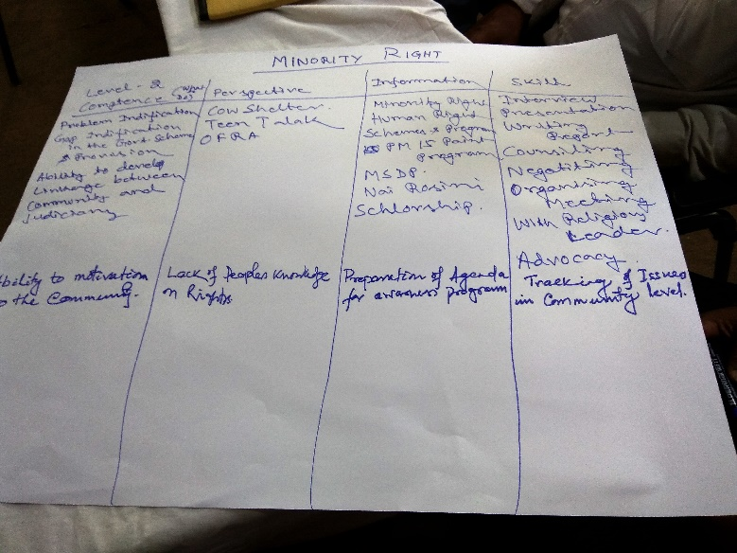
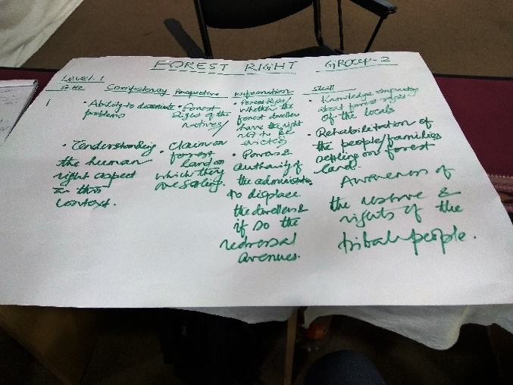

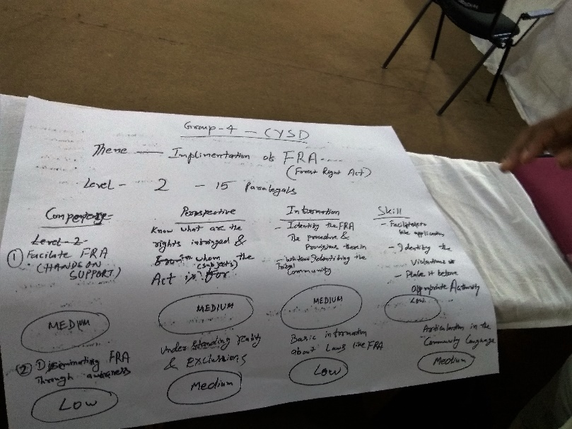

Day 2
30th March, 2017

Review and Feedback:

- Methodology:

At the inception of day 2, the participants were asked to answer 2 questions with a view to recapitulate the previous day’s sessions, while also understanding the purpose of the same.
They were asked to ponder and answer 3 questions:

- What happened?
- How did it happen?
- Why it happened that way?
Few of the responses from the participants are enumerated below:
What happened? | How did it happen? | Why it happened?
Introduction | It was a formal introduction. Name-organization-one expectation- what is legal empowerment to you. | - To understand the expectations of the participants from the training. Need assessment  - Learning environment  - Attempt to focus attention on the training.  - Outlet to express views  - All experiences can be synthesized into one sentence.  - Ability to articulate and be precise as a trainer.
Recall incidents up to 7 years and up till last 7 years. | Group work | - Getting in touch with self. Self- disclosure.  - Knowledge building  - Small skills of trainers. Eg: making effective use of charts, voice modulation  - Experiences through principles. Drawing out from motivating factors.
Metaphorizing the Access to Justice System | Input on metaphor-input on ecosystem-A2J | - Image choosing: so that there is clarity.  - Role of paralegal  - A2J system  - Way of articulation  - Situation analysis  - What are the hurdles, possibilities, challenges in the system  - Volatile surrounding  - Enhancing creativity and logic  - Inter-connectedness  - Integration and segmenting.
Developing definition of paralegal | Metaphorizing and identifying paralegal in the ecosystem. | - To understand the qualities of a paralegal  - Its roles.  - From the general to the specific methodology.
CSJ’s work with Paralegals | Presentation made by the trainer on CSJ’s work with paralegals. | - Helped to know about CSJ, what are the activities of paralegals that can be done.  - When we acquire something from a group, you always supplement it with information to add-on.  - A vision of what is paralegalism was given.
Levels of Paralegals | Presentation | - To facilitate deeper understanding into the competency grid.

- Conceptual Underpinnings:

- Review and feedback is an effective way of understanding how much the group has been able to internalize the previous day’s sessions and its purpose.

- It also helps the trainer understand the group’s grasping capacity along with planning the next day’s session ahead of time.

- Insights and other observations from Trainer:

- The trainer mentions that during the first day a mistake was committed in the exercise where the participants were asked to develop a definition of a paralegal. The mistake was that that, as a trainer she did not seal the methodology of coming to the definition of a paralegal. The activity was left mid-way where only one group had mentioned the definition. None of the other groups completed the task and neither was it followed up by the trainer.

Session I

“Developing Competency Grid”

Reviewing the performance of the groups of the previous day, the trainer pointed out that the next step would be to refine the grid. The trainer elaborating the process mentions that, one needs to imagine how many total training days would be available. Along with number of days, and desired number of events. The training design should adhere to the principle of input-action-reflection. It cannot be a single event, but that which involves fieldwork and reflection on the same.

Freezing the focus:

The trainer explains step by step the essentials of making a competency grid in accordance with the training events planned for each organization.

- Fix the number of days spread over number of events.
- Based on the competency grid, assess the emphasis to be given to each element of the competence grid and convert it into number of hours.
- Spread out various elements of the competence grid over the number of days depending on how early or late one would like the element to be addressed.

As an example: if 10 days are available and 8 hours/individual then, a total of 80 hours is available. Whatever elements are low on the grid that needs to be given more time.

Emphasis flow
Event 1 | Day 1 | Day 2 | Day 3
 | Identity of paralegal/  Basic human rights understanding | Skill of holding awareness camp | Application of selected laws / identification of issues
Event 2 | Day 1 | Day 2 | Day 3

Conceptual Underpinnings:

- Training are designed in a way where we can map competency grid, level assessment of the group and role based levelling can be done. More can be achieved in a training if competency is already mapped.

- There are ways of doing the mapping of competency grid. We can make questionnaires, telephonic interviews. Based on that we can formulate the competency grid. Sometimes we already know the group or we can imagine.

Step 1: Fix total no. of days and total no. of events

Step 2: Allocate time for each element, based on the emphasis you want to give on that element

Step 3: Decide which element you will like to be covered in which event.

For example: Fact finding as a skill: police power and investigation as a topic needs to be covered in 1st event. Subsequently, second event needs to cover fact finding as a skill.

Steps 4: Tick every element in the competency grid (Output 1) and ensure that all elements are covered. Look at the flow of designing the sessions: amount of information, skill and perspective should be involved each session. The flow should make sense.

Step 5: Take elements from each day and spread them over sessions.

Step 6: Tick every element in Output 2 (Freezing of focus) to ensure everything is addressed.

Step 7: Design Output 3 (Event design) with the sessions for the assigned number of days.

The trainer enumerating the steps explains that, the aim should be to design each session which integrates information, skill and perspective. There should be inter-connectedness of all elements with one another.

Methodology:

The participants were asked to orient the people who joined the group on the second day. In furtherance with the previous day’s sessions, the task was to freeze the number of days, number of events, hours available and allocate time to each element in the event. Participants were asked to work in respective group as per organization.

Inputs from the trainer:

Thereafter, after the steps are completed, for purposes of review it is to be kept in mind that:

- The levels match with competence.
- Participant level (High, Medium, Low) keeping in mind the role of the person, even if he is going to play a role of level 2 or 3.
- Look holistically and not in segments
- Distinguish between skill and competence. Competence is bigger than skill. Skill contributes to a competence. For example, to be able to be a good counsellor, speaking, empathy, listening, motivation is necessary. Therefore, it is a competence.
- One element (of information, skill, and perspective) may be repeated in several competence.
- It is fine, based on approach taken, to have something listed as competence in one design and as skill in another design. For example: in problem identification, FGD and listening would be competence. But if you are training data collectors, then FGD will be a skill. Depending upon the approach.

Session II

“Inductive and Deductive methods of learning”

The trainer begins by explaining to the group the two different methods of learning. Deductive learning approach and inductive approach mean:
- A deductive approach to instruction is a more teacher-centered approach. This means that the teacher gives the students a new concept, explains it, and then has the students practice using the concept
- Inductive instruction makes use of student “noticing”. Instead of explaining a given concept and following this explanation with examples and practice.

For example:

Deductive application:
Under the SC/ST Atrocity Act, one can ask when the act was passed. Main ingredient is that a non Dalit is a perpetrator, and a Dalit is a victim. If thus is not proven then SC/ST Atrocity Act will not be chargeable.

Inductive application:
One will do something that will make you notice this difference.

The trainer explains how the approach matters and how you educate to notice. She remarks that mostly the approach has been the deductive approach. Inductive method equips you to learn on your own. We use it interchangeably as per convenience.

Conducting a guided dialogue Exercise

Methodology:

One participant was asked to volunteer within the group to conduct a 10 minute plenary debate on “In our trainings law is only taught as a lecture with other activities to interspace it to make the day interesting.”

Conceptual Underpinnings:

The exercise of conducting a plenary debate ensures that sessions are participatory in nature which engulfs the participants to interact on legal aspects as well. It also ensures better analysis as both the sides of the coin are being assessed. In the alternative, it helps a trainer to understand its group. The group’s level of conviction and whether the previous day’s sessions have been internalized.

Insights from the group:

- In the plenary debate some believed in the proposition while some did not. Some thought that it was important that some lessons in law be given in lecture mode. The seriousness will not remain if not given theoretically.

- Participants for the proposition believed that interpretations are important aspect of law and therefore it can be taught via only lectures.

- Participants against the proposition believed that participants should know basic things. Thus, group discussion is an important tool. Presentation are important to facilitate discussions on law.

- Some believed that case studies are important method not just lecture method. Case studies brings in individual opinions. Anything can happen in participatory way. Lecture method is not a 2 way participation method. It is boring.

- A real life incident can be used as an example to educate law. It will re-instate memory.

Insights from the trainer:

The trainer asked the participants to reflect on the way the volunteer conducted the debate. What he did well and what could have been better?

Responses from the group:

What he did well?
Mobilized the group
Interaction
Acceptance level was good
He took initiative
Time bound

What could have been better?
He could have divided the groups into two- for and against.
He could have used cards- yes, no, agree, disagree

Session III

“Alternate Legal Education (ALE)”

- Introduction

The trainer begins by asking what we have in mind when we hear the words ‘alternate legal education’ Information flows from one mind to another. But when we talk of ALE it focuses on relating facts and feelings. It integrates attitude skill and perspective in a holistic manner.

Unless information is linked with personal life and its relation it makes no sense. For example, when judges were sensitized they were informed about Juvenile Justice Act, but we are unable to establish feelings-expectations connect. Thus, the attitude of the judge does not change. Since hearts were not touched.

ALE aims to link heart and mind. It focuses on how to learn rather than how to teach law. For example, in Criminal Procedure Code, there are many different kinds of sections and offences but what is important is to know how to read the law. To be able to find the answer.

ALE is combination of input and self-work, experience, self-reading reflection, pre contact session, post contact session.

Principles of ALE:

- Law is not a standalone subject it operates in a context: familiarity is important of the context.
- Information is not enough: it should move a person into action.
- Accompaniment and mentoring is important. Their issues at the field need to be addressed. Senior people etc.
- Need to build a person and her identity must be addressed: Who am I? What is my identity? It can be of a self-sufficient person.
- Training is contextual: it keeps changing. What work that person is doing at the field.
- Different people, learn differently
- Move from information to motivation: pain, contradiction, dreaming
- Facilitate learning without spoon-feeding
- Ensure sufficient practice of basic skills
- Create opportunity for experiential learning: experience related learning.

Self:
- Who am I? Where do I want to go?
- Getting in touch with historicity, revive that.
- Break I into different fragments of new I.
- Mentors are important in breaking shackles of deficit and creating a new I.

Components of context:
- Context building from process of developing perspectives and placing self.
- Exposure has to lead to transformation of identity and creating a new I.

Content:
- One learns when there are problems.
- Integrated
- Heart mind body balance

Role of mentors:
- To guide, steer, inspire
- Not to spoon-feed while facilitating learnings.
- Mutual trust supervisors need not be mentors and the dependence-co-dependence-interdependence shift should be planned.

Material used: Reading material regarding ALE handed over to all participants.

- Stills- Photo frame-‘Jhalki’ exercise

- Methodology:

The participants were divided into smaller 5 groups. They were asked to prepare a still (photo frame) on the theme assigned to them namely, domestic violence, contract labor woman, woman facing custodial violence, witchcraft, and sexual violence. They were asked to spend 5 minutes on thinking and come up with a still on their respective themes.

- Inputs from the Groups:

Groups | Theme Assigned | ‘Jhalki’
1 | Domestic Violence | 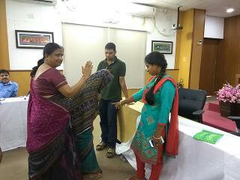
2 | Contract Labour related violence on women | 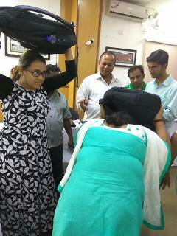
3 | Woman facing Custodial Violence | 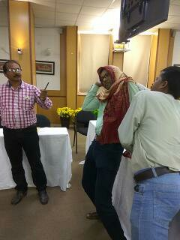
4 | Witchcraft | 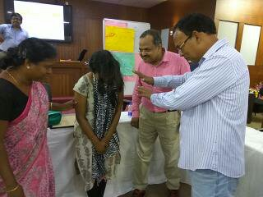
5 | Sexual Violence | 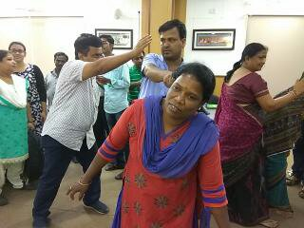

- Conceptual Underpinnings:

The purpose of the activity was to ensure that the participants can bring out the creativity in them, so that they can capture live experiences and put it into effective communication as a ‘jhalki’ so that it can be a starting point for further discussions. One single photo or a still leaves much greater impact than any other form of communication.

- Insights of the trainer:

The trainer while explaining the exercise, mentions that this is an important tool used by a trainer. A ‘still’ has potential to awaken powerful emotions within a person. Vulnerability is a powerful starting point to start dialogues. It revives historicity. These stills are powerful way to communicate the conditions of women in general. The understanding and sensitivity increases and it compels one to think. It plays on the softer side of emotions when shown such role plays. It touches upon various problems women face in life.

Understanding forms of domestic violence- Exercise

- Methodology:

Participants were asked to identify 3 women that they are close to. Following which they were asked to look at the definition of domestic violence and what provisions of domestic violence apply to them. The participants were made into groups of 3 each sitting side by side and first they were to reflect individually and then share with group members.

- Conceptual Underpinnings:

The exercise aimed to bring about a heart and mind connect while learning how to read and interpret law. It was an attempt made to make external internal. This activity seeks to play on the vulnerability and thus evoking powerful emotions to gain understanding into various forms of violence faced by women.

- Insights from trainer:
The task was called off, since the group was not completely receptive to the instructions of the trainer. A heart mind connect was not established in the activity.

Simulation on conducting village awareness programme- Exercise

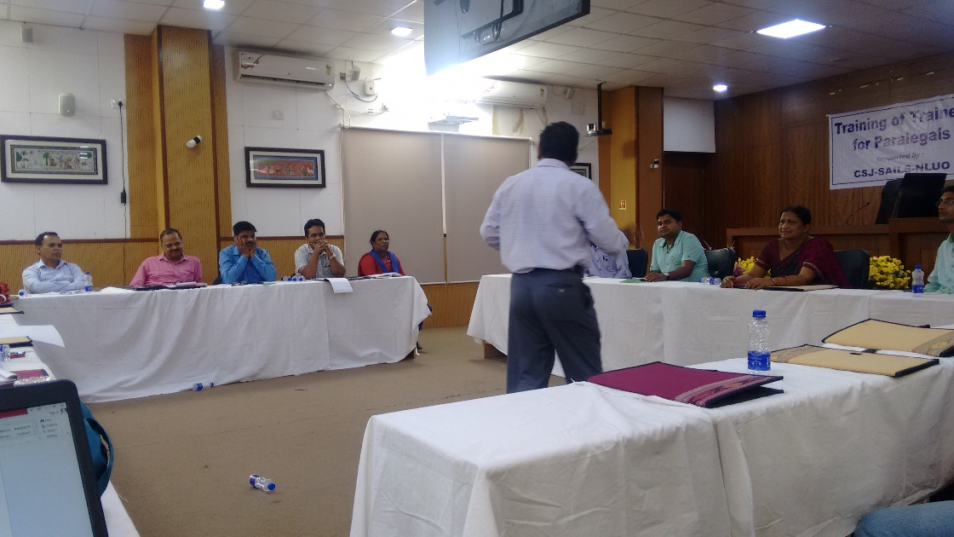

- Methodology:

One participant from the group who was thorough with the PWDV Act was asked to volunteer to conduct a mock village awareness programme on Domestic Violence Act for 15 minutes. He/she was to imagine all participants present in the training as men of the village. Later, a feedback would be done on the performance.

- Conceptual Underpinnings:

ALE focusses on concentrating on facts and figures and relating principles with feelings and expectations. The method used here was simulation. Drawing from individual’s lived experiences.

- Insights from the group:

The trainer posed few questions to the group as part of feedback on the volunteer’s performance. Excerpts are as follows:

Did he promote the objective making one stand against violence? Was he able to address the issue of violence?
Most of them answered in the negative, while some thought that he did answer.
How was his entry?
Most participants answered that he should have showed more respect to increase rapport building.

Voice modulation: commanding and aggressive.

Should it have been different? Listening should have been more. He was not letting others speak.

He did not talk about the subject much. Heart mind balance was missing. Only mind connection.
He was hurried- since time bound- high energy

- Insights from Trainer:

The trainer raises the pertinent question, i.e when should we use simulation as a method? It is used when there is a mix group which knows and which knows less. People who know more can give information and people who have less knowledge can learn from them. It would create a space for interaction and learning from each other in exchange.

Understanding layered questioning

The different kinds of layered questions are, direct, indirect, application and extension questions. Following are the examples of the questions:

- Direct question: question to which the answer is direct in nature. When was the Domestic Violence Act enacted?
- Indirect question: where you have to read more than one provision to find answers to the question. In a case study, does DV apply in this case?
- Application question: Does this provision apply here?
- Extension question: When a law is given to you and you have to inter connect 2 acts. How will S.125 apply with limitation?

- Methodology:

The participants were divided into 5 smaller groups and asked to draft one direct, indirect, application, extension respectively.

Groups | Questions
Direct Question:
What is domestic violence, what are constitutional provisions?
Whom to go for appeal?
What can a woman get after filing under this Act?

Indirect question:
Presented in form of case study, what are the remedies available to her under DV?
Application question:
which family member is not covered under the DV Act.
Extension question:
S.125 CrPC, victim for relief provision. Mental health connection.
 | Direct question

- Conceptual underpinnings:
To provide a deeper understanding into how questions can be used as an alternate source of legal education.

Before the day came to a close, the trainer assigned a task for the participants. The participants were divided into the same groups and they were asked to design a 15 minute session on the method assigned, which integrates perspective, information and skill in it. The following themes were assigned:

G1: Dalit atrocity using role play
G2: Labour rights using question
G3: FRA using case study
G4: Custodial violence using story
G5: NREGA using drawing

Day 3
31st March, 2017

Morning Session

Review and Feedback:
The 3rd and the final day of the training started off with a round of review and feedback from the group regarding the previous day’s sessions.

What happened? | How it happened? | Why it happened?
Recapitulating the previous day’s sessions | Individual and group reflection.  Method used: inductive and deductive learning method. | - For importance of sessions  - Reiteration of sessions  - Grasping power and memory  - What was right and what was wrong
Designing competency grid | Recap all the steps in the making of competency grid. Explanation of 6 steps in detail. | - To understand how much time we take to design sessions.  - Importance given to sessions.  - Clarity of outer limit.
3 things done differently for trainings i.e the new methods | - Competency mapping  - Need based assessment  - IPS integration  - Group levelling | Any learning block, faced by the participants?  - To revise the way we learn.  - To keep an open mind, to learn new methods of training and choosing the best of both methods.  - Timing should be accurate. We should be able to put in the actual time required for each session instead of placing an imaginary time frame.
Input on Alternate Legal Education (ALE) | Presentation made by the trainer on ALE. | - As it focuses on how to learn, instead of teaching.  - To build conceptual understanding.
Plenary Debate | One participant was asked to volunteer to conduct a plenary debate with the group on “law should be taught only via lecture method” | - Learning to make sessions participatory which contain legal aspects as well.  - To make learning open.  - Letting everyone speak and hear.  - Pros and cons are being put in center.  - For better analysis. Everyone will hear from both sides and build on both sides of the coin.  - To understand my own understanding regarding the group. To understand the conviction of the group and whether they believe that Law as a lecture method
Still-photo frame exercise- demonstrations | Making stills according to the theme assigned to each group. Peer review of the same. | - For understanding the importance of communicating via stills/pictures.  - Understanding of the different forms of violence against women.

Other observations from the trainer:
The trainer mentions that there was a mistake committed by her during the exercise of making a stills/photo frame on theme assigned. In the exercise the group was instructed to find the definition of Domestic Violence from the Act and check what applies to the women close to them. As a trainer, if the exercise requires the Act to be present in front of the participants, then a hard copy of the same should be present with them to enable them to effectively carry out the exercise. In the present case, the Act was not present with the participants, and in spite of that as a trainer, she continued with the exercise. The tool should be in hand, no assumptions should be allowed.

Session I

- Methodology:

In continuation with the previous day’s exercise, i.e based on the theme and method assigned to each group, the participants were asked to conduct a 15 minute session which integrates perspective, skill and information. All other groups will individually mark each group’s performance on the parameters of well done (point 1), good effort (point 2), needs improvement (point 3) along with reasons and what could have been done better. There will not be any individual feedback. The parameters for marking the groups were as follows:

- Heart mind connect
- IPS integration
- Time management
- Conducting skills
- Design skills
- Team work

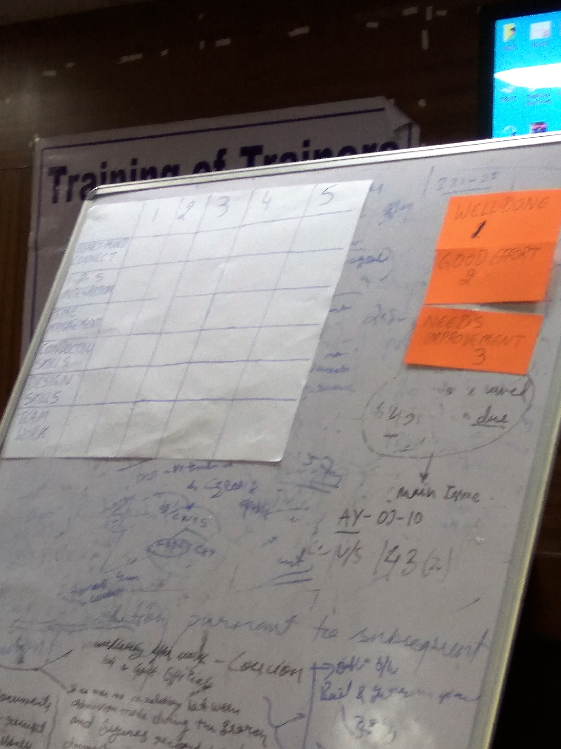

Group | Method to be used and theme assigned | Act
 | Dalit Atrocity via Role Play | The members of the group explained the SC/ST Atrocity’s Act. Spoke on untouchability and the socio-economic structure of the country.  They asked the other participants to volunteer to conduct a role play on the theme. A role play was conducted by engaging the other participants.
 | Labour Rights using Questions | The group took up Factories Act as their primary Act, and framed questions explaining different provisions. They displayed the act on the screen while reading the act and framing questions to others.
 | FRA using case study method | The group started by a brief introduction on FRA. They divided their tasks between the 5 members of their group. One person responsible for introduction, one person brief introduction on act, one person to narrate case study.
 | Custodial Violence by Story | One group member from this group narrated a story of a girl suffering custodial violence.
 | Via drawing | The members of the group requested all other group members to be seated group wise.  They took the theme of NREGA where a picture was shown to the participants. They were asked to point out the problems in the picture.  Subsequently, they requested the participants to write on charts what facilities were absent in the picture and draw the same on chart paper.  An incentive would be provided to those whose picture would be the best. After the drawing, they explained the provisions of the Act.

Thereafter, all the groups were asked to sit in their respective groups and evaluate other group performances. They were asked to mark on, well done, good effort, and needs improvement. A total of 15 minutes was assigned for this task. The responses of the groups are as follows:

Parameters | Group 1 | Group 2 | Group 3 | Group 4 | Group 5
Mostly awarded 2

Good subject but no connection.

What could have they done better?
They could have distributed sample case studies on the subject.
Heart-mind connect | 2 | Mostly awarded 2.  Reasons: there was coordination. Some heart- mind connect, however heart connect was missing. |  | 1 | 1-2  Heart connect needed more.  Picture used effectively.
IPS integration | 2 | 2  Over load of information  Skill and perspective was missing. | 2  No skill present | 1-2  No skill present as such. | 2  Skills not clear.  No new skill imparted
Time management | 2 | 1 | 1 | 1 | 1
Conducting skills | 2 | 2  The session was too fast, speaker and narrator not in sync.  Some miscommunication as well. | 2- 3  No coordination, speaking in different languages. | 1-2  Only one member conducted the session.  Should have been more participatory | 2  Cross talking was happening.
Design skills | 3  Very Loose design | 2- 3 they could have downloaded the acts | 3  They could have circulated case studies | 2  All did not participate. No flow. | 3-2  Conclusion was missing
Team work | 3  Only one member was presenting. Lack of team work. | 3- 1  Good effort but there was miscommunication. | 2  Well coordinated. | 3 | 1-2  Better coordination was needed.

Inputs from the Trainer:
Which was the best team performance?
Mostly, the groups agreed that Group 5 was the best team.
Best feedback?
Group 2 gave brilliant feedback.

Session II

Understanding Design- Exercise

- Methodology:
The participants were asked to roam around the premises and come up with one thing which according to them was an example of a good design. They were asked to assign reasons for the same and work in the same groups. The participants were allotted 10 minutes for the exercise.

- Conceptual Underpinnings:

Understanding what a good design is from our own surroundings, enables the participants to relate to their surroundings and create an active imagination, using creativity to the optimum. An inter connectedness can be drawn from the attributes of an object to what are the essentials of a good training design.

- Insights from the Groups:
The responses from the participants are enumerated below:
Example of a good design | Reasons for a good design
Presence of a Lounge outside | - Addresses utility  - Addresses needs,  - Filters what is unnecessary  - Roof is transparent, so therefore clear passage of light.
Painting in room | - Colorful  - Manifestation of Radha Krishna. Presence of history  - Cultural, mythological and historical elements.
Fire Extinguisher | - Mitigates untoward incidents  - Ensures safety and security  - Presence of CCTV cameras. Therefore, uses technology effectively.  - Responds to emergencies.
Seminar Hall | - Serves double purpose. It is a moot court and conference hall.  - Size is huge.  - Historical background.  - Represents diversity.
Placement of LCD Screens | - Systematic.  - Well placed and visible to everyone.  - Serves purpose  - Catches attention.

- Insights from the Trainer:
Drawing from the responses of the participants the trainer explained that, when a training module is designed it should be a mixture of all the above mentioned ingredients.
It should address needs, aesthetic, colorful, historicity, technology, eye catching, and be visible from every corner. Every person should be touched. Every element should be functional, systematic and well-placed.

Session III
Competency grid

In continuation of the exercise of making a capacity building plan, the participants were asked to proceed to Step 7 of making the design. Standardization of module is not done, since training is contextual and a possible design according to the group to be trained.
While establishing the goals of the sessions it is imperative that, on reaching Step 7 of the making a capacity building plan, we establish goals and try and list them down into the following parameters:
- What must happen in this session?
- Determine if possible in the time.
- Prioritize goals, set reasonable time limit.
- Organize goals in logical manner- inductive/deductive learning.
Thereafter, it is important to brainstorm and choose the best methods. For choosing the same it is imperative that we are creative, we can exhaust all ideas and take off either on our own ideas or other’s.
Select methods which meet best goals and select structures that meets the goals.
Assess the design to see if it meets goals, whether it targets the audience. The design should feel good. Evolving with the group is necessary.

Inputs from the trainer:
- The many advantages of this training design is that there is enough flexibility in this design, to evolve with the group. A challenge can be faced with in case where a resource person is being called for the training. It is imperative that we assign them in a specific slot, what you want them to deliver, and specific inputs. For example, a training on fact finding would need a forensic experts. We would assign not more than an hour and thus, integrate in the design.
- Integrate with resource persons for specific needs and purposes. If integration is not done then this design would fail.

Concluding the session, Mr. Shahariar and Ms. Sheta informed the participants of a questionnaire developed by them which enquires as to how many participants will train and what kind of work will they be involved in. They were asked to fill up the form so that later they can be followed-up on what were their take-away from this training.

Session IV
‘Dream MIS’: MIS as a learning tool

- Introduction
The trainer elaborates that an important need of all organizations to check how to monitor legal awareness programmes.
- Methodology:

A hand-outs of ‘Dream MIS’ was provided to the participants containing different formats of Field unit report, monthly report, primary information report, etc. which would help in monitoring and evaluation of cases. Participants were asked to read in their own groups from the hand-outs distributed. It should be in context with what is useful for that person. Thereafter, analyze what you want to add, delete and carry out every month. Each group was given one document and to study the same.

- Contextual Underpinnings:

Monitoring, Information and System (MIS). Monitoring is the regular observation and recording of activities taking place in a project or programme. A good MIS system can reveal the overall impact of the activities. Not only are the individual efforts highlighted, but where efforts are being put in at the different part of the organization. It helps in the critical analysis of the intervention at various parts, in identifying the overall trends, growth and directions.

- Inputs from the trainer:
Due to paucity of time, the exercise of each group and their analysis on what they would want to add, delete or subtract for their own field areas and planning for the month could not be completed. The trainer provided few inputs on the working of the MIS and its advantages and utility in monitoring the legal programmes.
Monthly planning report:
- Taking the example of a monthly planning report, the trainer explains from the view point of a supervisor to check whether the forms are being filled properly by the field unit members. For this, we need to simultaneously check whether information provided in the field unit report is tallying with monthly planning report of the member of the unit throughout the working period.
- If a thematic is not moving ahead, this analysis can provide an insight into why the issue is not progressing.
- Trends of members handling more case and activities within the team. This can provide insights.
- Trends as to the part of the month where most of the visits are organized. Whose responsibility and next step can be checked.
Primary information report:
- A primary information report contains details of clients, case proceedings, case results of the unit etc.
- Tally the case analysis in Field Unit Report.
- Follow-up the sources from where the cases are coming
- An analysis can be done of how effective our outreach strategies are.
- What are the types of services we are providing.
- Who are the people who can be our volunteer base.

Village visit report:
- The ‘Village Visit Reports’ will have the details regarding the visits, discussions, and issues of the villages and helpful people met.
- Tally the village visits reported in Field Unit Report.
- Follow-up of the Shibirs and Issues of the villages taken up by the unit
- What type of issues do we get from which village.
- Whether strategy is working or not.
- Whether our volunteers are being able get to the root of questions regarding that problem.
- Are we able to identify needs?
- What is the reason they are going to the village? Is it just meeting, or fact finding, research?
- Who are we contacting? What kind of issues are we talking about?

Legal awareness programme report:

The ‘Legal Awareness Reports’ will have the details regarding the issues addressed, duration, media used, cases coming, questions, learnings, and attendance of the ‘Shibir’.
1. Tally the legal awareness programme details reported in Field Unit Report.
2. Follow-up of the cases coming through the legal awareness programme
- What kind of media, what issues are we addressing?
- Whether we are using cultural forms, different media to be used.
- What kind of people are gathering?
- What kind of questions crop up?
- Follow up issues
- What kind of issues at the village?

External stakeholder report:

The ‘Stakeholders Visit Reports’ will have the details regarding the organization, meeting, discussion and follow-up.
1. Tally with the visits reported in Field Unit Report.
2. Follow-up of the Stakeholders contacted and objectives addressed
- Who are we meeting and for what? Follow up, decisions taken etc.

Fact finding report:
- Investigation quality, follow up action, etc.

Closure

Moving towards closure, the participants were asked to pen down the answers to the following questions, first individually and then discuss in their own groups:
What were your key insights?
What did you like about the training?
What could have been done better?
Feedback and Key sharing of learnings by groups:
Groups | What were your key insights? | What did you like about the training? | What could have been done better?
 | To learn the role of trainers for impacting legal services to the society.  The techniques methodology and the basic approaches to be inculcated to be a good and efficient trainer. | Participatory approach was lively and interesting. | Blending of field visits and practical case studies would have been more educative.  The time frame was quite insufficient for such an important aspect.  Refresher programme after a break will be sustainable.
 | Understanding of competency grid  IPS was well directed  Dealing of participants was good. | Participants of stakeholders  Well direction by trainer  Energy throughout the training | Some confusion regarding the venue could have been avoided  Logistics should have improved.
 | New approach to understand the role and responsibility of a trainer who will conduct training on legal empowerment. | Training by the trainer was interesting and creative.  Methodology used in training, useful and informative.
 | Role of paralegals  Competency grid- IPS  Know about legal aspects  Training module | Group exercise  Realization- experience  Active participation- participatory approach  Facilitation was good | Real life situations of a victim could have been shared  Discussion on a particular act  Proper management could have been done.
 | Understanding roles and responsibilities of paralegal/ ALE  Competency assessment  Preparation of training module. | Methodology, approach, tool, training techniques | Training logistics should have been at the same place  Shortage of water
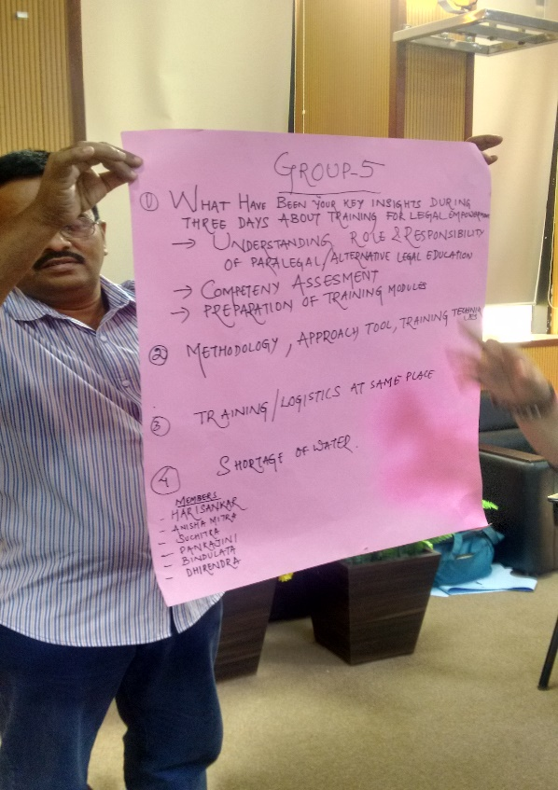

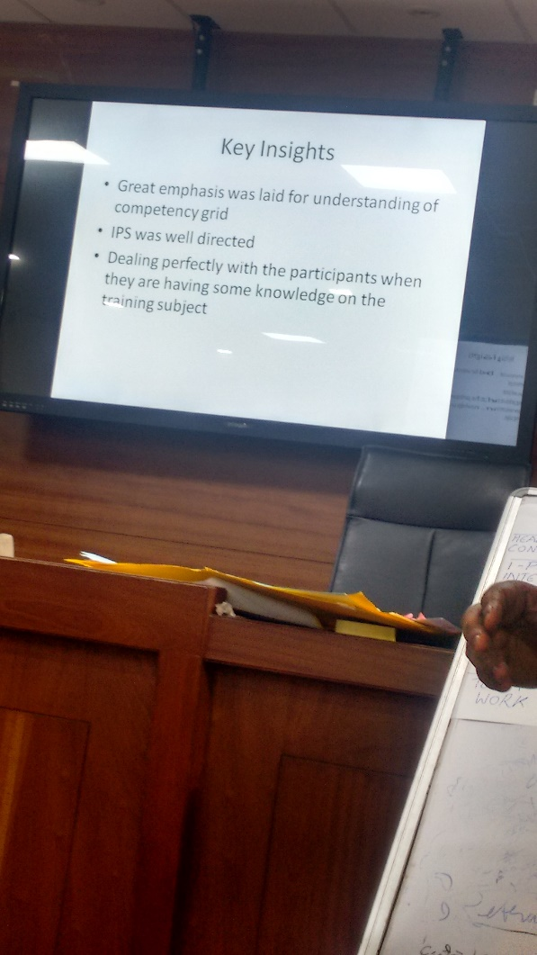

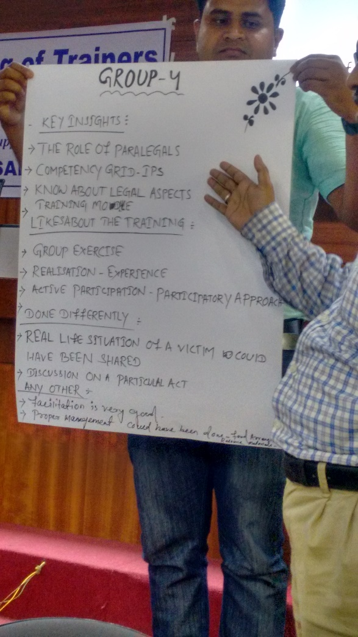

Concluding Session

- ‘Closing Words’

Suman Bhattamishra, Faculty Coordinator, NLUO: Ms.Suman began her concluding words by thanking her entire administrative team of NLUO who helped in organizing the programme. She mentioned that her initial exposure to CSJ and training of trainers was first in Sri Lanka, when CSJ proposed to collaborate with NLUO. The journey had started then, and hopefully this event has helped all the paralegal students and community college students as well. Ms. Suman apologized for the inconvenience caused due to some mismanagement regarding logistics and venue. She concluded by appreciating the zest and enthusiasm with which Ms. Nupur conducted the sessions and participants who were present for the sessions diligently.

Registrar, NLUO: She began by saying that she felt privileged to be a part of this. To see the people involved here, like Ms. Nupur who are from social sciences background and how to go ahead with a paralegal programme-movement which is not taken up by anyone else in the country. She also mentions how NLUO is one of those only institutions which has taken up this alone in the country. Thanking Ms. Sheta and Mr. Shahariar from Bangladesh for being present and for giving their ideas and participation for the event. She mentions how all participants are like little soldiers and hoped that everyone benefitted with the event. The word paralegal often connotes someone who isn’t a lawyer but they are into it. She concluded by saying that the institution will look forward to more such programmes in the future and the awareness should spread for others to join in.
Mr. Shahariar Sadat,Academic Coordinator,Centre for Peace and Justice (CPJ), BRAC University: Mr. Shahariar in his concluding words remarks that, it had been his pleasure to be present for the event and thanked everyone for the enthusiasm that they have shown. On behalf of CPJ-BRAC University he mentions that the journey has started and that there should be more activities in future.
Ms. Nilufa Sheta, BRAC Univeristy: Ms. Nilufa began her concluding address by thanking everyone for the hard work that they had done. She mentions her keenness to establish paralegalism in South Asia, as part of the main goal. She closes by extending her gratitude to Ms. Nupur for the brilliant facilitation and sincere thanks to NLUO for their hospitality and cordial support.

Distribution of certificates: Ms. Suman requested the Registrar and Ms. Nupur to distribute certificates to all the participants.

