[Type the document title] | [Pick the date]  [Year]
[Type the abstract of the document here. The abstract is typically a short summary of the contents of the document. Type the abstract of the document here. The abstract is typically a short summary of the contents of the document.] |  | [Type the document subtitle]

Using Legal Strategies as Core to Activating 10 Pilot Entitlement Centers in MCDs/MCBs

Approach to Strategize Rehnuma Work
2013-2014

BACK GROUND: India is a country which chose to put the socio economic rights in the realm of Directive Principles Of State Policies at the time when the Constitution was formulated. Subsequently judicial activism by various enlightened judges expanded the scope of Art 21 of the Constitution to encompass within its purview, the various socio economic rights like the right to health or right to water, right to food etc. Subsequently, due to strong lobbying by the civil society and a responsive government, there have been efforts to bring in legislation that address many of them, be it Right to Food [the Bill related to the same in still pending] Right to Education, Right to work [Mahatma Gandhi National Rural Employment Guarantee Act] etc.
What this has done is to make some of the socio economic rights justiciable and give them a legislation backing. Simultaneously, what it does is create several parallel mechanisms that will respond to their violations. Unlike earlier, where the only remedy that will be available for the violation of socio economic rights would be the High Court or the Supreme Court under Art 32 or Art 226 of the Constitution, there are administrative or quasi-judicial mechanisms that have been created to respond to violation of these rights.

Many of the socio economic rights still remain in the realm of schemes and government programmes. In order to ensure the implementation of the same, it is important to make the relevant machinery accountable.
There is an overall apathy of the government when it comes to these schemes. However, when it comes to the minorities, they face double discrimination. In addition to a generally unresponsive State, they also have to deal with bias towards them, which makes it even tougher for them to obtain these rights.
Working on the socio economic rights of the minority community needs, as a first step, an understanding of the ground reality. In order to do so, it may be good to take recourse to the UNICEF’s inclusive programming as a framework, which focuses on the end point and process both as rights.
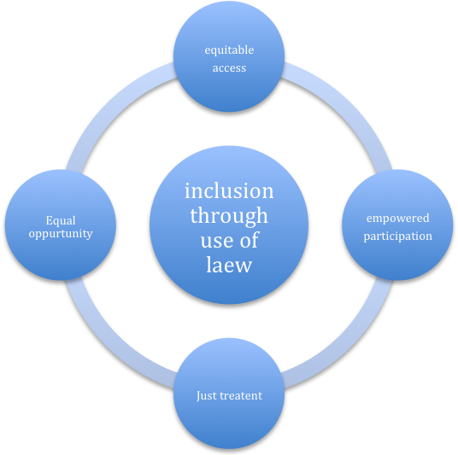
Equitable Socio economic rights depend on the following factors:
EQUITABLE ACCESS
- Establishment of citizenship: therefore voter identity card, UIDN, PAN no. Passport and other forms of identification become important. While there is nothing official that stops the minority community from having these, there could be situational factors , in addition to the negative bias against them that can have a role to play. From ex , many fishermen in Amreli district of Gujarat do not have these because they spend eight months on the sea shore and get left out when the lists for I cards etc is being made. An effort needs to be made to identify and eliminate such factors.

- Establishment of socio economic status:
- The Supreme Court, in its orders in the case of PUCL Vs Union of India has given detailed guidelines for implementation of seven schemes related to right to food. The Food security Bill is being debated and is likely to come into force shortly. However, it is important to ensure that there are no systemic factors that exclude the minority. For example, in Bodoland in Assam, most houses use tin sheets and therefore are excluded from the below poverty Line criteria.
- license to do business, especially those not in sync with religious sentiment of the majority community, like beef shops etc. or even normal licenses to manufacture and sell
- Access to credit by Private has to be facilitated and compliance with the Reserve Bank directives on this matter have to be monitored

EMPOWERED PARTICIPATION

1. Membership of trade associations , self help groups panchayat’s other civic elected bodies needs to be facilitated to avoid exclusion of the minorities and a push from civil society on this count is very important
2. Ensuring Admissions to young people to State and Private academic institutions where reservation policy exists or doesn’t is important to ensure that “ reverse exclusion” i.e setting up of minority institutions in the absence of admissions in main stream does not happen.
JUST TREATMENT
1. Grievance redressal for a, private sector, public sector and the State are inaccessible due to non-availability of legal and quasi-legal services.
2. Monitoring right to food, right to education and entitlements of quality health infrastructure.
3. Making civil courts and consumer fora sensitive /accountable through judicial pronouncements.
EQUAL OPPURTUNITIES
- It is here that law has a smaller role while affirmative action and public policy resource allocation, reservations and capability building will be critical. The projects attempt as building human resources from disadvantaged communities would go a long way.
- The issue of gender equality within the community will also be an important aspect and, hence, ensuring women’s right to property and related aspects will also be addressed.
- The pilot would also throw up implementation challenges in setting up such centres in all MCD districts. Thus, the learnings would help pioneer the effort. This is important in the light of the fact that we have already been able to push the concept of entitlement centre in the Ministry of Minority Affairs. Handholding the setting up of the same will be a fruitful exercise and will ensure that it does not end up being a exercise on paper.

The following laws will be used during the project:
- Muslim Personal Law (Shariat) Application Act, 1937
- The Right of Children to Free and Compulsory Education Act or Right to Education Act 2009
- Madarsa Board legislation in each State setting up the madarsa Board
- Central Madarsa Board Bill 2009 [ lobbying for finalization and passing by the legislature
- National Food Security Bill [ lobbying for finalization]
- Supreme Court Guidelines on right to food
- Art 19 of the Constitution on freedom of trade
- State legislation related to cow slaughter
- Guidelines issued by the National Human Rights Commission regarding the Internally Displaced People and UN Guidelines on Rights of Internally Displaced People.

Thus as the Indian State is eager to showcase its inclusive growth and also gain the moral space of being a secular democratic nation, the institutional mechanisms for protection of minorities through the minorities commission and the special ministry of minority association, will benefit from the study.
Least but not the least, this project may be a path breaker in approaching socio-economic rights work in India as a collaborative venture.

