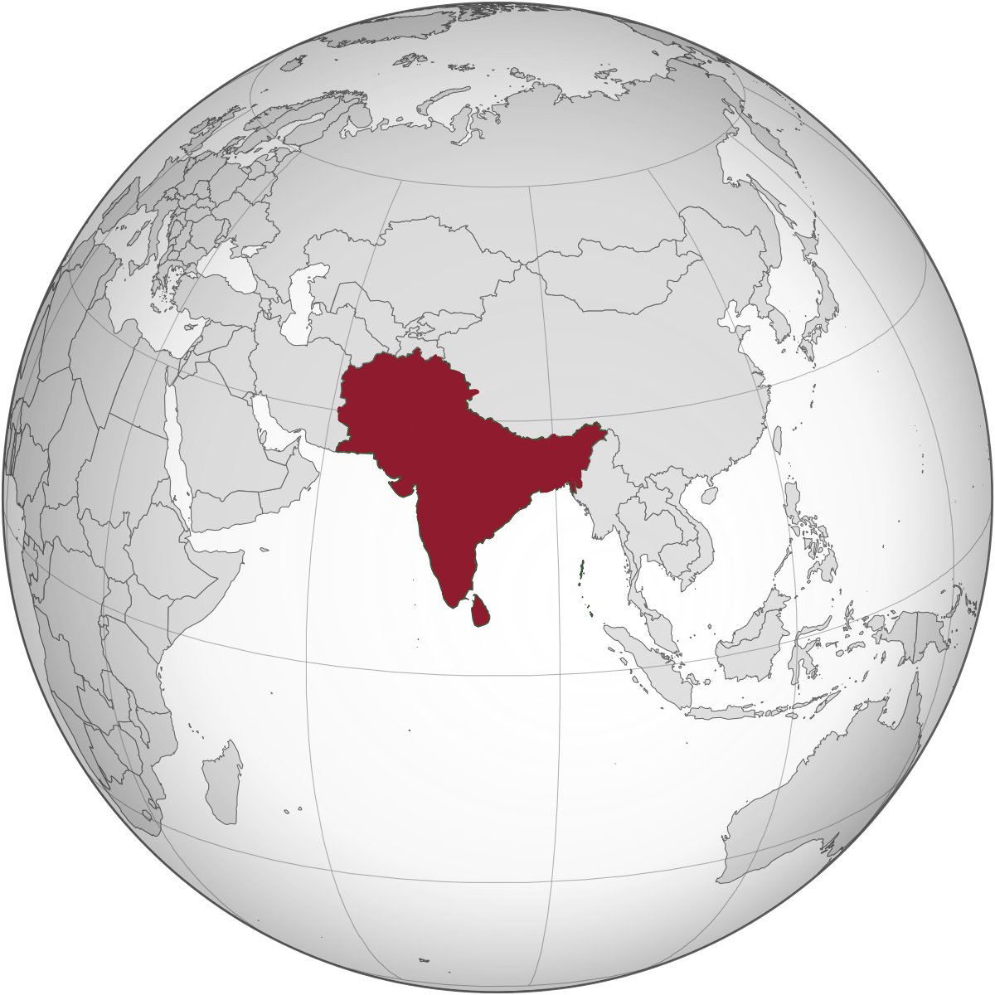

**18th to 23rd July, 2016**

South Asia Institute of Advanced Legal and Human Rights Studies (SAILS), Bangladesh

Centre for Social Justice (CSJ), India

United Nations Development Programme, (UNDP), Pakistan

Rural Support Programmes Network (RSPN), Pakistan

|  |  |
| --- | --- |
| A Report | **Training of Trainers at Islamabad** |

|  |
| --- |
|  |

# Training of Trainers

# at

# Islamabad

18th to 23rd July, 2016

Day One

Introductory Session

Mr. Gagan Sethi, Vice-President of Centre for Social Justice introduced the workshop and its objectives to the participants. The objectives were:

1. To develop common understanding on principles of Alternate Legal Education (ALE): Mind/Body/Heart

2. To develop designs, tools and methodology for paralegal training

3. To enhance skills in paralegal training

4. To provide a sharing platform for consolidating learnings from experiences of training/ managing Rule of Law/Access to Justice Programmes

Mr. Gagan hoped that the training programme will serve to help the participants understand not how to teach law but how *not to teach law*. The programme will also be a common search for the meaning of ‘Alternate Legal Education’.

A lot of the people here are also managing their own paralegal programmes, which may go by different names but they are really involved in the core work of deepening of democracy. Coming from countries that are young democracies, ‘deepening of democracy’ in our respective countries is perhaps the appropriate framework to adopt for our training.

An important thing to note before starting the programme was that ‘paralegal’ is not defined only by skills but it is an identity. This led us to the introduction by the participants.

**Methodology**

Participants were given 5 cards of different colours. They were asked 3 sets of questions. Answer to each question was to go up on a card of a particular colour.

First set of questions for the introduction were: *1. What is your name and what is your role in your organisation? 2. What is your Mother’s name?*

Next set of questions were: *1. Which of my mother’s attributes are in me as a trainer? 2. When I say Access to Justice in my country, what is the one thing that makes me proud and what is the one thing that makes me sorry?*

The final question was: *What should happen at this training and what should not happen here?*

The participants took 10 minutes for the cards and then came up and read out their answers. The answers have been collated below (see also, annexure for day one):

|  |  |  |  |  |
| --- | --- | --- | --- | --- |
| **Which of my mother’s attributes is in me as a trainer?** | **When we say “A2J” in my country: One thing that makes me proud:** | **When we say “A2J” in my country: One thing that makes me sorry:** | **What should happen here?** | **What should not happen here?** |
| **-Punctuality of my mother- getting up early (on time performance)**  **- Organization**  **- Leadership**  **- Selflessness**  **- Helpfulness**  **- Every mother understand her children- I take that from her**  **- Clear communication**  **- Patience**  **- Attention to all**  **- Hard working**  **- Having interests of the students at the forefront**  **- Enthusiasm for education**  **- Proactive assessment and evaluation**  **- Justness and fairness**  **- Kindness**  **- Responsibility**  **- Passion**  **- Calmness in the face of hopelessness**  **- Good listening skills**  **- Open to questions**  **- Problem solving** | -Lawyers’ collective movement  - General knowledge of the law  - Robust law and constitutional structure  - Justice system  - Laws for protection of women, etc.  - Pro-women laws  - Increasing public awareness (*Afghanistan*)  - Network of legal aid offices  - Increase in legal empowerment initiatives  - Pro-activeness for formalizing laws for communities | -Non adherence to SDGs  - Lack of access to justice for women and children  - Lack of awareness in the society  - Lack of implementation of law  - Inequality of access to justice  - Security as an impediment (Afg)  - Patriarchal and feudal system  - Lack of commitment towards nation and national issues (Afg)  - Lack Government’s interest in A2J  - Slow, time consuming and delays  -- Cost of litigation | - New Learning  - Punctuality  - Open sharing without fear  - Sharing of knowledge about access to justice in other countries  - Interactive learning  - Role plays  - Group work  - Positive attitude towards learning  - Practice of adult learning methodology  - Getting inspired by experiences from everywhere  - Build bridges  - Insights about how to train most effectively  - Learning about making law accessible  - Sitting arrangements should be proper | - Intensive session  - Unnecessary criticism  - Political discussions  - Criticism of countries  - Ranking  - Formal advices  - Lengthy lectures  - Groupism  - Late coming  - Taking the training for granted  - Falling asleep  - Differences becoming conflicts  - Spoiling environment  - Focus on theories |

**Inputs from the Trainers**

People must have asked you your father’s name, mother’s name lies in the underbelly and this was an effort to bring her out. Mother, who is the first teacher, has the most crucial role in the process of learning.

*Session:* Storytelling and Learning Principles

**Methodology**

The participants were asked to form groups of four persons each. They were then supposed to revisit the first 15 years of their lives and remember a positive story when somebody (their mother/ father/ teacher or anyone else) did something that made them learn, something that they practiced even today. They were to share that episode with others in their groups.

In the next round, the participants supposed to share another story in the last 10 years of their adult lives, where they did/ act in a way which made someone else learn who acknowledged it even till today. Every group will now have 8 stories with them. Based on these questions the participants were asked to complete the sentence “People learn best when __________”, culling out 5 principles of learning.

After about an hour of discussion, the participants came up and presented the principles that they had culled out. They also shared with everyone the “whiffs” of these stories. The principles that the participants drafted can be found as annexure for day 1.

After this exercise, the participants were asked why they did what they did just now. It was a question that will appear again and again during a course of this workshop.

**Inputs by the Trainers**

During the session, the trainers pointed out that ‘story-telling’ was an art that we are unfortunately losing. Throughout history, South Asia was known for storytelling and its methods. It was perhaps time to bring it back to trainings. Every one of us carries stories with us in our bellies. It just needs a needle to bring it out. The trainers also presented what they considered as norms of learning. These were:

1. Self manage time
2. You are your own authority
3. I am my own authority
4. Each is accountable to his/her own behaviour
5. No praise, no blame, non-judgemental
6. Just acceptance of what is
7. Search for many ‘right’ answers
8. Self propelled learning is the key
9. As you invest so you reap
10. Participated Interest “Here & Now”
11. Bring out self as a resource
12. See others also as a resource
13. Safety is a collaborative creation
14. Facilitators do not have the answers/ solutions
15. What makes meaning to you is important

*Session:* Paralegal as an Identity

**Methodology**

The participants were shown examples of various animal ecosystems (refer to annexure.) They were now asked to:

*1. Draw the A2J ecosystem in their respective country on a chart*

*2. Name different actors in the A2J system and metaphorise them as animals/ non-living thing on the chart*

*3. As a metaphor chosen as a paralegal, name the traits (roles and functions) and further name at least 6 traits and put each trait on separate cards*

*4. Name the relation (with connecting loops) between this animal (the paralegal) and other animals/ non-living things (actors) on the chart.*

There were 4 groups: 3 people in a group for Afghanistan, 6 people who were part of the RSPN and networking programmes, 5 who deal with Access to Justice and the rest who would look at the larger A2J situation in Pakistan.

The groups came up and presented the metaphors on charts they had prepared.

**Insights of the Participants**

Reflecting on this session, the participants said that it helped remind them of the traits that a paralegal should and helped them understand the relationships with other stakeholders in the A2J framework.

**Input by the Trainers/ Conceptual Underpinnings**

The best way to understand an identity is to see that identity’s relationship with others. In the last few years, people have stopped managing people as cadres and hierarchies but as ecosystem. The definition of ecosystem was shown to the participants, this was: “An ecosystem is a community of living organisms in conjunction with non-living components of their environment (things like air, water, mineral and soil) interacting as a system.”

An ecosystem rests on the belief that anything might affect anything and everything. If you took away one species in an interdependent system, you affect the whole system.

With this, the relevance of metaphorising was also underlined. It might help the participants locate the paralegal in the A2J ecosystem. While certainly, metaphorising was an incomplete way of looking at things but it could tell you some traits you identify with.

*Session:* Training with Empowerment Logic

**Input by the Trainers**

Training has three historical location- military, religion and family. Even today thus, training styles that are adopted at most places reflect sensibilities of these institutions.

Trainings have traditionally adopted the “Goal-Efforts-Means Tree”. However, this is not the logic of empowerment. For empowerment to be achieved, you need a counter metaphor: that of an upside down tree. The message of such a upside-down tree is the following: rather than starting with a preconceived concept of what a tree structure should look like, let’s start first with the roots (i.e. bottom-up), and then see what tree can potentially grow out of that. If you take care of the roots, the paralegal will construct knowledge themselves.

The upside down tree:



*Session:* Evening Readings

**Methodology**

The three readings that were taken up in the evening session were:

1. On Freire’s “Pedagogy of the Oppressed” Chapter Two- The Banking Approach

2. Appreciative Inquiry

3. Setting up a Learning Environment

The readings were divided amongst different groups. After each group read the readings, they were asked the key learnings from them and to connect it to what had happened during the day.

**Conceptual Underpinning**

The session allowed the participants to reflect on the day’s activities through the lens of the specific readings chosen. Letting the participants read different readings and articulate its key highlights is itself an exercise focusing on comprehension and communication.

Day 2

*Session:* Reporting Group Presentation

**Group**

Mr. Ahmer, Mr. Atif, Mr. Wazir and Mr. Ghulam Shabbir

Presentations annexed.

**Methodology:**

Every day, a group of 4 to 5 persons would divide roles and attempt to summarise the previous day’s proceedings, capturing the tasks, processes, discussions, group energy levels, photos, presentations and the charts prepared**. They would answer the questions: *1. What did we do? 2. How did we do it? 3. Why did we do it the way we did? 4. What are the key learning and insights?***

The reporting group was also asked to analyse the learning sheets that were to be filled by the participants at the end of that day. They we asked to capture how they worked together as the reporting group.

Other participants were asked to provide feedback to the participants on the contents/reflections/insights of the presentation and add if there was something that was missed out.

The first reporting group made up of Mr. Ahmer, Mr. Atif, Mr. Wazir and Mr. Ghulam Shabbir presented their report from the previous day focusing on these questions.

**Insights by the Participants**

Most of the participants felt that the group had done a good job. One of the comments from the other participants was that their “feelings” were not captured by the presentation. Learning norms too were left out.

**Conceptual Underpinnings**

This was an example in “double-loop learning”, allowing critiquing of and learning from the reporting group’s presentations.

*Session:* Learning Styles

**Methodology**

Input session by trainer on different learning styles based on the handout given to participants the previous day. Participants had to fill their inventories to identify their key learning styles.

**Conceptual Underpinnings**

The session flows from the previous day’s session in order to contextualise the different ways in which people learn by the use of a self-learning tool which enhances the group’s understanding of human species as programmed to learn differently in multiple ways. Therefore, a single methodology in a training programme will be exclusive and counter-productive to the objective of enabling learning. The method seeks to establish that a training space has to be inclusive, and diverse by taking into account the different learnings styles of the trainees, and hence any design of a training session must account for different learnings styles.

**Input from the Trainers**

The trainers spoke about four main learning styles which include:

* Abstract Conceptualization (Thinking)
* Reflective Observation (Watching)
* Active Experimentation (Doing)
* Concrete Experience (Feeling)

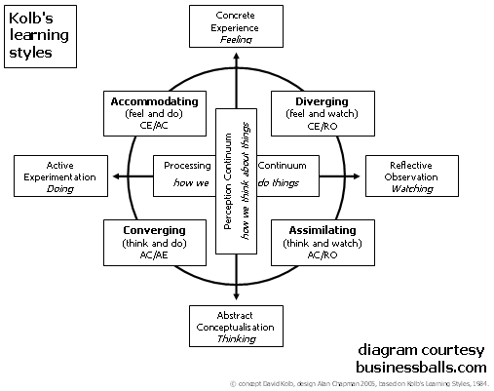

*Session:* Traits of a Paralegal

**Methodology**

The participants were asked to slot the traits of paralegals that they had come up with the previous day on the basis of where they thought the traits fit on the body of the paralegal.

An outline of a paralegal had been drawn. On this body, the head represented dreaming, the heart represented being, the hands represent having and the legs represented doing.

**Conceptual Underpinnings**

*[From Sri Lanka ToT Report]*

*Use of Metaphors:*Through the use of metaphors (symbolism, visualisation and imagination) the participants are encouraged to synthesise common traits of all the groups and build the profile of a paralegal, thereby constructing the identity of the paralegal. *Using metaphors supports a holistic construction of the paralegal, more specifically the heart and brain reflecting values and knowledge and their interplay.*

*Use of Body:*Participants use the human body as a site for locating the paralegal. The use of the human body as a canvas brings in a greater sense of intimacy in the group. Playfulness during the exercise adds to the sense of camaraderie and intimacy which brings the group together and the process ensures a stronger internalisation of the learnings and insights. Further, instead of speaking conceptually, this exercise is more realistic identifying with something as real and close as our bodies. This helps participants to construct roles and the identity of a paralegal as not somebody just out there, but constructing it from within the body.

*Session:* Definition of a Paralegal

**Methodology**

Based on the discussion on the previous day, in groups of 4, the participants were asked to arrive at a definition of a paralegal. After all of them came up and presented their definitions, there was a discussion on the same.

Later, after the day’s sessions were over, one person from each group would be nominated to form another group that would come up with a common definition.

**Input of the Trainers/ Conceptual Underpinnings**

If you make them into ‘identity’, paralegals will expand their roles. It’s a political question. Arena where I am a trainer I must know the ecology of the whole thing.

As a trainer, if you do your job well, it will lead to a greater overlap between a lawyer’s role and a paralegal’s role.

Empower based training might result in reorganization of the ecology. Health system was once controlled by doctors. Nurses were in a supporting role. Health delivery and prevention ecology has now moved out of MBBS degree. Roles such as those of community health workers and health managers have unquestioned importance in healthcare.

The result might also be conflict between two players in ecology but that is not always bad.

*Session:* Competencies of a Paralegal

**Methodology**

The participants were required to divide themselves into groups, and discuss what the competencies that a paralegal must have are.

The participants were them to break them into the categories of information, skills and attitudes.

**Input by the Trainers/ Conceptual Underpinnings**

The trainers provided the participants with the definitions of competency.

“**Competency** is the ability to do something successfully or efficiently. It is the ability of the individual to do a job properly; set of defined behaviour that provide structured guide enabling the identification, evaluation and development of behaviour in individuals; adequacy/ possession of required skill/ knowledge/ qualification/ capacity; cluster of related abilities, commitments, knowledge and skills that enable a person to act effectively in a job or a situation; sufficiency of know or skills that enable someone to act in a wide variety of situations.”

Competency can also be understood with the help of this diagram below:

Perspective

Knowledge

Information

Skill

The trainers provided two examples of this competency- information/perspective/skill analysis. This can be found below:

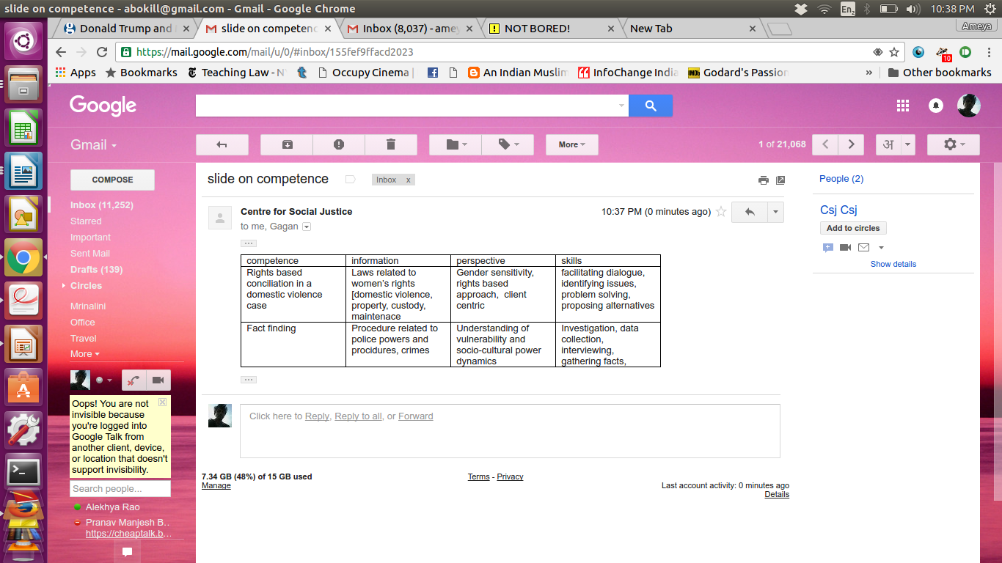

*Session:* Teaching Law- Best Practices

**Methodology**

The participants were divided into groups of 4. They were asked to share within the groups details of a session that they had taken in the past in which they had dealt with law. The groups were asked to present how they went about this session and list the various methods that were shared in the group.

The session designs that were made by the participants have been annexed.

Day 3

*Session:* Common Definition

**Methodology**

The group that had worked previous evening presented the common definition culled out from other individual definitions.

**Input of the Trainers**

Is paralegal a professional? – This is a question that should be asked.

What we are trying to do is that definition gives some scope to give an identity. Identity has an aspect of dignity.

One more thing provides dignity to professions- this is the oath. Eg. the Hippocratic oath that the doctors are made to take provides dignity to them and is an instrument of identity. Trainers can help them build an oath.

Definition is a cornerstone of identity. Based on this, you can build a code of conduct and then an oath. It makes it a triangle.

*Session:* Reporting Group Presentation

**Group**

Ms. Salma Khalid, Mr. Muhammad Saqlain Sarkani, Mr. Muhammad Asif and Majid Sattar.

Presentation annexed.

**Methodology**

See previous day.

**Input of the Trainers**

[On the quiz taken by the RG] For adults at least, good question is that which does not have one answer. The point in adult learning is not easy and difficult question but a good question.

There is no good learning style or bad learning style. Your training style depends on your learning style. Knowing your learning style, how does this influence your training methods?

Trainers should be the worst critiques of themselves. Never be satisfied.

*Session:* Readings

**Methodology**

The participants divided into two groups took 15 minutes to read the readings on “5 Stages of Group Development” and “Understanding Group Processes” respectively and apply what is said therein to the processes of the previous day.

*Session:* Alternate Legal Education

**Methodology**

The participants were told that they will now adopt two identities: One of themselves and one of any one paralegal that they have trained or value. The trainers presented a slideshow on alternative legal education.

**Input by the Trainers**

Principles of Alternate Legal Education:

* Alternative legal education integrates experience based self-work and input sessions as a pedagogical methodology.
* The focus of the methodology must be on “how to learn” rather than “teach” law.
* Facts and principles must be related with feelings and expectations.
* One-shot training sessions are not effective. Capacity building programmes must be structured across a specific time period into a fixed number of contact sessions.
* Basic strategy to be adopted during trainings is to focus on skill building and sensitization rather focusing solely on information dissemination. The overall training design should be prepared keeping in mind that only few training sessions can be possible within a limited time frame.
* Different people learn differently. Therefore, different learning styles must be incorporated into the training designs.
* Learning must be facilitated without spoon-feeding.
* Ensure sufficient practice of basic skills.
* Create opportunities for experiential learning.
* Law is not a stand-alone subject it operates in a context.
* Mere information is not enough, it has to be supplemented with perspective and skills.
* Accompaniment & mentoring is important throughout the process and after.
* Need to build a person’s identity as someone who is committed to the legal process and has a stake in it.
* Training is contextual and hence will vary in design depending on the target group, thematic, geographical location, availability of resources, level of knowledge/skills, etc.

The role of the trainer should be:

* to facilitate learning without spoon feeding.
* to ensure sufficient practice of the skills.
* to initiate and guide discussions on various areas with the objective of sensitization.
* to provide reading material.

*Session:* Freeze Frame

**Methodology**

The participants were again divided yourself into 4 groups. They were each to represent prisoners, women, labourers and tribal persons respectively. They were asked to imagine that a camera was zooming and stopped on the group on any given day. The question: What would it capture?

The participants were to become this frame for 5 seconds. After the groups did this, photos were taken of them in action and all of them were presented before the plenary. The participants were asked to decode all the pictures.

**Pictures**

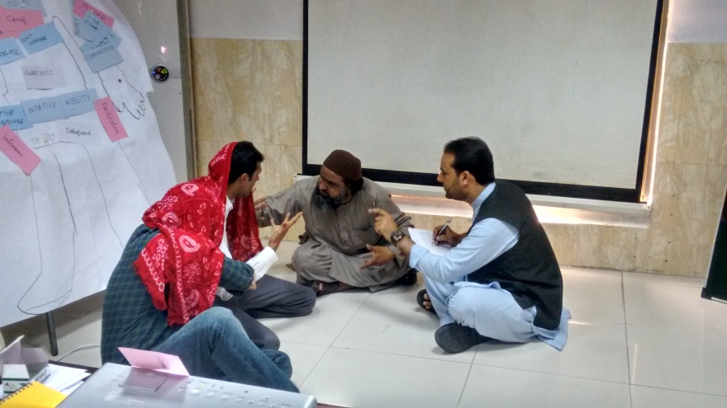

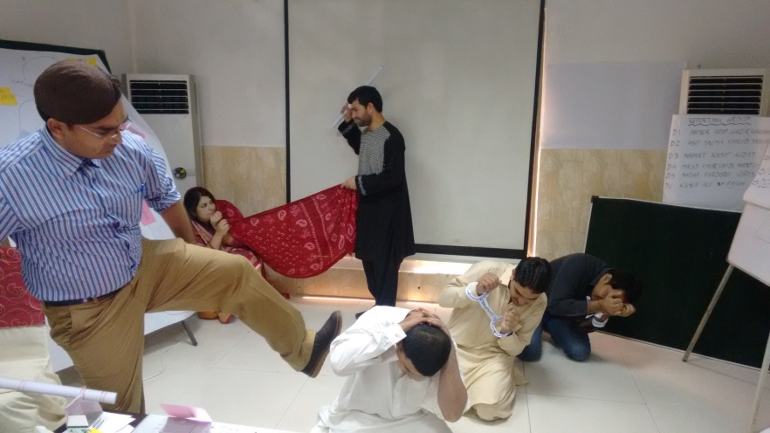

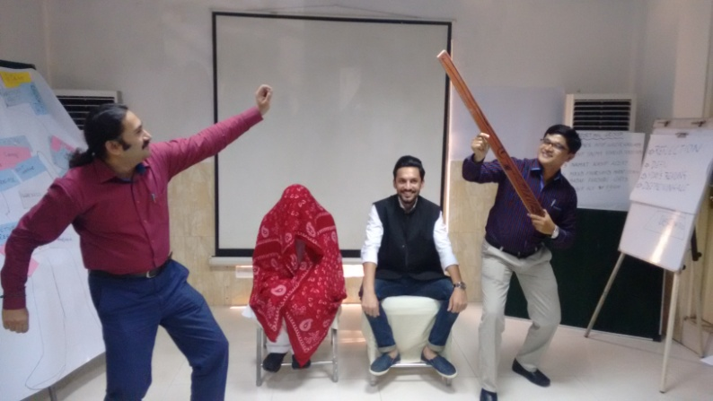

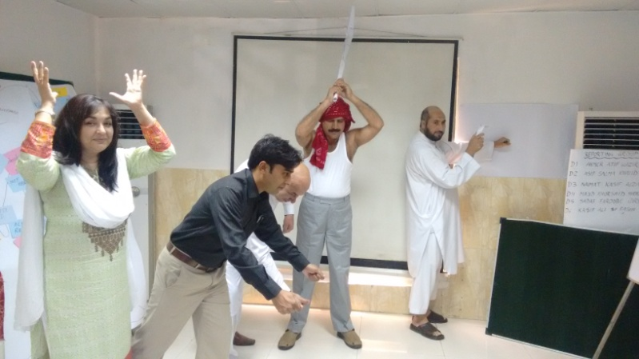

*Session:* Rights Violation

**Methodology**

In the same groups as before, the participants were asked to identify provisions from the Universal Declaration of Human Rights that are applicable to rights violation of your specific thematic. They were also asked to identify parallel provisions in the Constitutions of Pakistan and Afghanistan and explain the differences between UDHR and the Constitution. Two groups chose the Constitution of Pakistan and two chose the Constitution of Afghanistan.

They were to then make a presentation on the correlation/ differences between the UDHR and the Constitution.

In the next round, the groups were asked to identify relevant law that applied to the violation, procedures that could be adopted and the relevant authorities.

*Session:* Domestic Violence

**Methodology**

In groups, the participants were asked to think of a women around you, someone you love, and answer if there was any instance in their lives for which the definition of domestic violence would apply. The definition that they were asked to work with was that under Indian law.

*Session:* Role play

**Methodology**

Continuing the same groups, the participants were asked to perform a seven minutes role play on specific types of domestic violence that is given to you. These kinds were: verbal violence, physical violence, sexual violence and economic violence.

The groups were then called upon to perform the role play and then ask other participants relevant questions that will lead the plenary to decode the play.

On the third day only one of the groups could perform their role play. This was the group with the topic ‘verbal violence’.

Day 4

*Session:* Reporting Group Presentation

**Group**

Mr. Naimatullah Jan, Mr. Kashif Nazir and Mr. Izatulla

Presentation annexed.

**Methodology**

See second day.

**Input of the Trainers**

[On the discussion over the common definition of paralegal presented on the previous day] The important point is that we must value the work that paralegals carry out. What trainers end up doing is undermining their effort and building up the perception is that boss is always right.

***Session:* Readings**

**Methodology**

Four more readings were taken up for discussions. Participants were asked how they related what they read with what happened during the day.

Bloom’s taxonomy of all the other readings is the one that a trainer ought to read.

Training is an art of asking a good question. If you see and reflect what kind of questions you ask, you will know what kind of answers you will get. Stupid questions lead to stupid answers.

If you use the lecture method, you can only ask questions about information. If you make the paralegal apply their minds, you can ask him why and how questions.

*Session:* Role Plays Continued

**Methodology**

Refer to previous day.

**Inputs from the Trainers**

As a trainer, processing the simulation is the crux of supporting learning. Knowing or being able to conduct the game is not a competency that a trainer sports. Rather steering the group towards learning is the task.

While decoding, you can ask questions with different kinds of focus:

1. Standard content focus- What happened? What did you feel?

2. Process focus- When you saw this, what did you think?

3. Feelings focus- What did it make you feel?

4. Diagnosis focus- What should you do about it?

It’s also important for a trainer to be able to deal with jokers in the group. Every group has a few of them but they are encouraged by the entire group. They get their power from the group and the rest of the group is actually doing the jokers a huge disfavour by acting and disturbing through this person.

[On the role play on economic abuse] Even if the play has successfully displayed economic abuse, as soon as you use physical violence in the role play, the focus would shift to it.

*Session:* Input on Questions

**Methodology**

The participants are given input on kinds of questions in relation to law. Participants are asked to form questions from each category on RTI laws. Groups chose 4 different laws including some regional laws and that in Afghanistan. They are asked to present these questions.

**Input from the Trainers**

4 types of questions:

1. Direct questions—where the answer is directly available in text

2. Indirect question-where two or more facts need to be combined to arrive at an answer

3. Application question-where a fact situation needs to be related with a provision of law

4. Extension question-where two or more laws need to be referred to

*Session:* Designing a Session

**Methodology**

In groups, the participants were asked to take any provision of law of their country on the specific thematic given and use one method that already been used and one method which has not been used to develop a 45 minute session where you can clearly show the heart-mind balance.

The four themes given were: women’s property rights, domestic violence, honour killings and sexual violence.

In the session design, the participants were asked to specify:

1. Name of the topic

2. Objective of the session

3. Relevant legal provision and other information

4. Stepwise methodology

5. The heart mind balance

Two of the groups came up and presented their sessions, the rest were reviewed by a peer review process.

The session designs prepared by the participants form part of annexures.

**Input from the Trainers**

Different methods perform different functions. Case studies on the other hand get paralegals to apply provisions on the other hand storytelling is a way to evoke the heart connect.

You can construct joint narratives through asking participants to tell their stories. Decoding is then facilitated by trainer after the session.

Another way to use stories is to begin with them and get your paralegals to apply the law to those stories.

Appreciative inquiry which is a process of learning talks about four stages in a cycle:

--- Dream--- Discover--- Design ---Deliver--- Dream---

Activities in a training programme should embrace these stages.

Trainers must remember that th trainees can only retain about 7 to 11 minutes of a training therefore things that they need to remember are very little in a good training.

[On group 2’s use of role play] “Role play” in this case was used as as a film/ drama not a role play per say. Role plays are usually evocative/ provocative and performed by participants. Here, group 2 used a play to feed in information more creatively.

*Session:* Collective Review of the ToT

**Methodology**

The trainers asked the participants to review the training programme they have undertaken, from day 1 to day 5. They asked if there were things that could be done differently, if there was something the trainers shouldn’t do and something they must do over last two days and what are their views on the programme.

**Responses of the Participants**

1. Some of the methods that were introduced here will definitely be adopted. I will try fit in these things at different places during my regular work.

2. The day’s session practical and useful, something concrete that they will take back with them.

3. Many of the methods can even be used for teaching children kids.

4. Our trainings only had knowledge focus, with this ToT, we think perspective and being able to relate things to context are also important. Learning styles inventory told us one methodology for all 20 paralegals is not enough. We accept the challenge ahead.

5. We will have to design keeping in mind learning and not merely giving content.

6. What we learnt about roles of paralegals, definitions and reporting was crucial.

7. First think that clicked with me was building the identity of the paralegal. So far we have thought of it only as a job description.

8. Peer learning is important to processes such as these.

9. With proper training, paralegalism will open up new avenues for jobs for youths.

10. Thing that we can still do over next two days is attempting to develop training material and learning techniques to do that.

11. Perhaps over the next two days, there can be a discussion on the way forward.

Day 5

*Session:* Reporting Group Presentation

**Group**

Mr. Hijratullah Safi, Mr. Khurshid Alam and Mr. Majid Hussain

Presentation annexed.

**Methodology**

See second day.

*Session:* Training Style Inventory

**Methodology**

The participants were given a form to fill based on which they were identify their own training styles given in the training style inventory. Persons who had highest scores under each of the respective styles were asked to read the characteristics of that particular style.

The four styles in a pictorial form are given below:

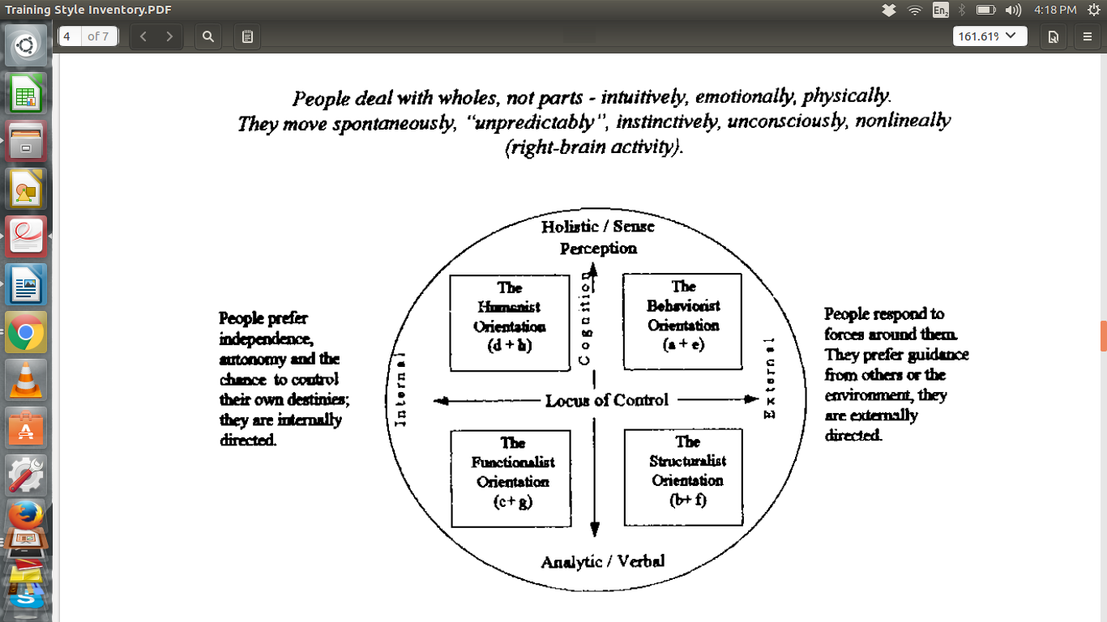

**Input from the Trainers**

There is no good or bad training style just as there is no good or bad learning styles. We should try to find our own blocks, work with these blocks and try to develop characteristics you don’t possess to become a more holistic trainer.

Whatever you are good at tends to become less effective like a knife loses its sharpness more it is used. You shouldn’t also let other parts of your characteristics be unutilized. It is possible to control your training styles.

*Session:* Designing

**Methodology**

In groups of three people made up of people who have spent less time together, the participants were asked to take a walk around the venue and identify something that attracts them as an example of a good design.

The participants were asked to click photos of it and write seven reasons why they think it is a good design.

The participants picked out different designs in the process and presented the reasons they liked it. The presentations can be found as annexures.

The participants were then given input on designing.

**Input from the Trainers**

Design is both an art and science. Beauty- elevates you. It exudes a kind of positive energy.

Some buildings are consciously designed some particular manner. If you go to a temple or mosques, there is an overt beauty but when you enter, you find a friendly space that makes you reflect.

Knowledge without application becomes external. We must make people become artisans instead of scientists.

Good training is partly practice into knowledge. Trainer becomes irrelevant when you start making knowledge.

You dream, discover, design and deliver.

*When one designs training sessions, there are certain things to be kept in mind:*

- Ask what you want to happen

- Determine whether it can be achieved in the time

- Prioritize goals and set reasonable time limits

- Organise goals in a logical manner: inductive or deductive

*Brainstorming methods include:*

- being creative

- exhausting all ideas

- taking off on you own or others ideas

*While selecting methods:*

- Select methods that best meet the goals

- Select structures to implement the methods

*While assessing the design, ask the questions:*

- Does it meet the criteria of a good design?

- Does it meet the goal?

- Does it feel good?

Next step is to revise the design: Go over the steps at least twice (we went over it at least six times before getting here)

One should remember the following diagram:



Different training methods (reading, lecture, etc.) are different in terms of involvement of the participant and whether meaning is external or internal to the learner. In a training design, a trainer would have to choose more than one of these to link the learning needs of the participants to the training objectives.



The entire process of the training can be represented in the following diagram:



If one were to condense accepted designing principles they would go this way:

1. There are no recipes but there are formats and approaches.

2. It is clear but not a set of instructions.

3. It is open ended but can vary and even be quite constrained.

4. Invites participation with an interesting challenge.

5. It (preferably) justifies the main themes/ constraints/ goals.

6. It provides support for classifying entries (categories, modalities).

7. It provides general assessment criteria and rules but not a checklist).

*Session:* Engaging with Paralegals

**Methodology**

The participants were given input on engaging with paralegals and different levels of paralegals through a presentation.

**Input from the Trainers**

*The background against which CSJ’s paralegal programme started was this:*

- It was felt that social movements often lack legal rigor and this affects its outcomes.

- Very few organizations focus on access to justice itself.

- Paralegals have a diminished identity and treated as an “add on” to lawyers.

- There is also significant lack of clarity about the scope of their work

- When some of their work overlaps with that of a lawyer, bar associations feel threatened

*The paradigm shift that was brought to paralegal training was:*

- Creation of a distinct identity as a special cadre

- Arriving at the concept of operational paralegal

- Understanding that a paralegal is social worker “plus”

- Understanding that a good social justice lawyer has to be a good paralegal

- Seeing paralegal’s role not just in awareness or individual cases but in a systemic intervention

- Realising the importance of creating spaces within the mainstream

*The different kinds of paralegals that CSJ engages with are:*

- Single issue, single skill [eg. life convicts trained as paralegals for undertrials]

- Single issue, multiple skills [eg. for organisation working on specific themes]

- Multiple issue, multiple skills [eg. for organisations working on wide variety of themes]

*There are also four levels of paralegals for CSJ:*

*Level Zero*- has general information on law, is a community leader and helps us in organising meetings and fact findings

*Level 1*- has the ability to identify violations, refer them to us

*Level 2*- has the ability to address violations, give first level support

*Level 3*- does everything that a lawyer does except appearing in courts

*Strategies that CSJ has adopted over the years to create space for paralegals are:*

- Identifying existing spaces within government systems like the forest committees, Lok Adalats (people’s courts), mediation centres, etc. and train them

- Training paralegals and get them co-opted into various government mechanisms

- Lobbying with various departments to create new spaces for paralegals under law [Gram Nyayalaya Act, Nyaya Panchayat Act, Parent’s Maintenance Act etc.]

- Created a network called paralegal association which will push towards a transparent and accountable judiciary

CSJ also introduced “the circle” as a framework for paralegals to work in and defining the work they do. This is represented as following:



An important process in developing paralegals is following the framework of “input-action-reflection-fresh input”. It is a continued engagement with paralegals through regular meetings, assignments, etc.

Arguments for self sufficient paralegals are:

- Paralegal will have a life beyond the project

- Creates self employment for youth that impacts the community positively

- Prevents drop outs from the programme in search of better services

- Breaks the hegemony of lawyers and touts..if the training is good, the paralegal will be value oriented and will not exploit.

*Session:* Designing a Training Programme

**Methodology**

The participants were now asked to design their own training programmes. They were slotted into 5 pre-decided groups and provided details of the paralegal groups that they will provide training to and the themes that these will be on. The three participants from Afghanistan formed one of the groups. The groups were told that they could discuss and modify the details if they so preferred and other details such as social and educational backgrounds.



*The first set of instructions was:*

- Imagine the role that this paralegal is going to play

- Set the objectives of the training

- Develop the competency grid (see day 2 session on “Competencies of a Paralegal”)

- Place your group vis-a-vis this grid (score them low, medium or high).

After this, they were asked to develop a training design specifying details of each session on each day of the training and representing in the form of grids.

*The second round comprised of the following set of instructions:*

- Take each of the grid in the table that you have made

- Detail it out with appropriate methodology and time. (Try to work, if you want, in track change mode.)

- For each box give the following details:

- Objective of the session

- The Information/ Skill/ Perspective or a combination being addressed

- Relevant legal provision and other information

- Stepwise methodology

- The heart mind balance

The participants were asked to fill in the details for at least the first training capsule (3 days/ 2 days).

**Feedback from the Trainers**

The trainers provided feedback at the end of first round of work.

[Group 1]

In the present ToT we constructed definition of paralegals *from* identity. In your design, you enter the definition of a paralegal right away. Your target group may have difficulty in grasping the definition.

[Group 5]

You have made data collection as a skill to be imparted. Your one final day training session could also be made data centric in the sense you can tell them about utilization of data and taking them into understanding policy engagement, making the data they bring actually useful and importantly making them see this.

[Group 4]

Trainers might be inclined to have exposure visits but they also require facilitating to make sure the participants are getting something out of them.

[Group 3]

Tests are always bad ideas in trainings with adults. It doesn’t help equalisation of the trainer and the trainees. It is short of showing them their place. Evaluation may be done in more creative ways.

There is also a possibility to develop training design with participation. You can ask your participants- what should you be able to learn at this training?

Day 6

*Session:* Group Presentations and Video Feedback

**Methodology**

Working with the detailed design that was created the previous day, the participants were told the following:

- Pick any one session where you are dealing with law.

- Describe in 5 minutes, what is going to happen in the session.

- Take a 15 minute slot and do a demo assuming that the present group is the group of paralegals you want to train.

- This will be videographed and a feedback will be taken on the basis of the recording.

After the groups presented their session designs before the camera, the videos were played back and feedback was given.

*Session:* “Potential for a South Asian Network of Paralegals (Mr. Manzoor Hassan)”

The second session of the final day was a special video conference with Mr. Manzoor Hassan, Executive Director of South Asian Institute of Advanced Legal and Human Rights Studies (SAIL) all the way from Bangladesh.

Mrs. Hassan expressed regrets over not being able to make it to the programme but was happy that it had gone so well. He brought the participants up to speed with the conceptualization of this training programme across South Asia. He said that it began with the belief that there was an utmost need to engage larger legal community in the access to justice work and expand the community.

The trainings in Bangladesh and Sri Lanka before this had led to the creation of a fantastic network of persons devoted to paralegalism and justice in the region. This was the third of such trainings. The challenge before those working towards this is how to intensify the work. He believed that parallel processes such as that already undertaken in Pakistan through national ToTs will achieve this result.

In India and Bangladesh too, they were committed to bringing other NGOs together for a similar national process and there also stands the possibility of this process being carried out in other nations. While processes might differ, it is important to have a shared goal.

To achieve further synergies, SAILS has also established a new programme- M.A. in Human Rights and Advocacy open to people across South Asia. Trainers that have attended the present ToT might also be eligible to join and are encouraged to do so.

CSJ and other organisations have provided crucial inputs in the design and functioning of this programme.

Another work that has been undertaken by SAILS in Bangladesh is their modest research programmes on issues related to paralegalism and access to justice. Similar research programmes can be started in other places.

Concluding Session

At the concluding session, Mr. Shoaib Sultan Khan founder of the Rural Support Programme Network was the special guest of honour. Mr. Shoaib spoke about the circumstances that brought about the establishment of RSPN. Early in his social life, Mr. Shoaib learnt that the way to beat poverty is not mere reliance of the existing pillars of the Government but the bringing up of the ‘socio-economic pillar’- that of the people themselves.

What counts is working collectively in an organized manner not individually and supporting the community’s efforts. A reason RSPN and all rural support programmes in Pakistan have been successful is that they have managed to take the message to almost each and every household.

Mr. Shoaib proceeded to present certificates to all the participants and mementos for the trainers who had come from India. Mr. Gagan Sethi also presented Mr. Shoaib with a memento that he had carried from India.

Participant Mr. Kashif Siddique gave a short recap of the training and Ms. Sadaf and Mr. Hijratullah shared their experiences from the training and what they will take back from it.

With this, the Training of Trainers at Islamabad came to a satisfying conclusion.

Annexures

The annexures to this report can be accessed through here:

<https://drive.google.com/open?id=0B7jUnE2F7fW7TnVTRnIyTDdURlk>